Granite River Labs and KDPOF Collaborate to Deliver ISO-Standardized Automotive Ethernet Over Plastic Optical Fiber

ISO 21111 Enables Standardized Design and Testing of Optical Gigabit Networks

Madrid (Spain) and Santa Clara (California, US), August 11, 2020 – Granite River Labs (GRL), a global leader in engineering services and test solutions for connectivity and charging, and KDPOF, leading supplier for gigabit transceivers over POF (Plastic Optical Fiber), announced that a specification for 1 Gb/s optical connectivity in vehicles has been adopted by the International Organization for Standardization (ISO).

ISO published two new standards for in-vehicle Ethernet series 21111, forming the basis for reliable implementations of systems that realize in-vehicle 1 Gb/s Optical Ethernet as a physical layer. ISO 21111-3:2020 specifies additional features to IEEE 802.3bvTM, such as wake-up and synchronized link sleep algorithms. ISO 21111-5:2020 specifies requirements at the system level and a complete conformance and interoperability test plan for electronic control unit (ECU) providers that implement an optical 1 Gb/s physical layer as specified in ISO 21111-3.

“GRL is proud to support ISO-standardized Gigabit Ethernet POF (GEPOF) test services and automated test solutions,” said Vamshi Kandalla, Executive Vice President and General Manager of Granite River Labs. “Extending our automotive ethernet testing profile further supports automotive hardware developers, including ECU vendors, to conﬁdently deploy robust, interoperable products and technologies.”

“With ISO standardization of GEPOF, we and GRL jointly provide the network technology to enable new and emerging connected car technologies,” added Carlos Pardo, CEO and Co-Founder of KDPOF. “Carmakers and Tier1 suppliers benefit from integrated, compatible, and interoperable implementation based on our KD1053 IC and GRL’s competencies to perform conformance tests.”

Words: 269

Images

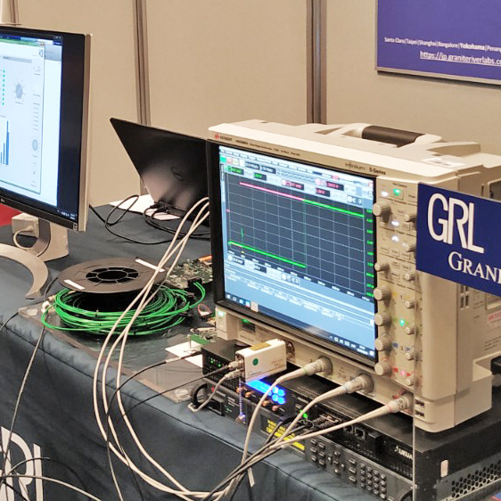 |  | Image 1 Granite River Labs and KDPOF collaborate to deliver ISO-standardized automotive Ethernet over plastic optical fiber  Copyright: KDPOF  Download: https://www.ahlendorf-news.com/media/news/images/KDPOF-Granite-River-Labs-ISO-21111-optical-gigabit-ethernet-H.jpg
Image 2: Vamshi Kandalla is Executive Vice President and General Manager of Granite River Labs

Copyright: Granite River Labs
Download: https://www.ahlendorf-news.com/media/news/images/Granite-River-Labs-Vamshi-Kandalla-H.jpg
Image 3: Carlos Pardo is CEO and Co-Founder of KDPOF

Copyright: KDPOF
Download: https://www.ahlendorf-news.com/media/news/images/KDPOF-Carlos-Pardo-H.jpg

About Granite River Labs

The world’s leading Engineering Services and Test Automation Solutions firm for connectivity and charging, GRL helps engineers solve tough design and validation challenges. GRL began in 2010 with a vision to provide affordable test services to help hardware developers implement digital interface technologies as they become faster, more complex, and more challenging to test. Today, GRL has worked with hundreds of companies supporting the adoption of new and emerging technologies from their worldwide test facilities and R&D centers. For more information, please see www.graniteriverlabs.com.

Granite River Labs Inc.
3500 Thomas Road, Suite A
Santa Clara, CA 95054, USA

Media Contact:
Quintin Anderson
Co-Founder & COO
T +1-408-627-7608
E qanderson@graniteriverlabs.com

About KDPOF

Fabless semiconductor supplier KDPOF provides innovative gigabit and long-reach communications over Plastic Optical Fiber (POF). Making gigabit communications over POF a reality, KDPOF technology supplies 1 Gb/s POF links for automotive, industrial, and home networks. Founded in 2010 in Madrid, Spain, KDPOF offers their technology as either ASSP or IP (Intellectual Property) to be integrated in SoCs (System-on-Chips). The adaptive and efficient system works with a wide range of optoelectronics and low-cost large core optical fibers, thus delivering carmakers low risks, costs and short time-to-market. More information is available at www.kdpof.com.

KDPOF Knowledge Development for POF, S.L.
Ronda de Poniente 14, 2ª Planta
28760 Tres Cantos, Spain
E pr@kdpof.com
T +34 918043387

Media Contact:
Mandy Ahlendorf
ahlendorf communication
E ma@ahlendorf-communication.com
T +49 89 41109402

