Funzin Integrates KDPOF ICs in New Devices “FAIP 3.0” and “Photon”

CES 2022: Joint Presentation of Optical In-vehicle Network Solution for Autonomous Vehicles

Madrid (Spain) December 9, 2021 – KDPOF, leading supplier for gigabit connectivity over fiber optics, proudly announces that Funzin, software development and edge AI solution company, have integrated their KD1053 IC and integrated KD9351 FOT (fiber optic transceiver) in the new Funzin AIoT Platform “FAIP 3.0” and Edge AI Device “Photon” for automotive. “An automated driving car requires networks capable of controlling and processing a great deal of sensor data,” explained Ms. Deuk Hwa Kim, CEO/President of Funzin. “Our automotive network solution features an Ethernet backbone environment based on plastic optical fiber (POF) to eliminate electronic wave interference.” The new system solution provides the gigabit communication infrastructure needed for sending and receiving high-capacity data. “We are happy to support the FAIP 3.0 and Photon with our new KD9351 FOT that, in combination with the continuing KD1053 IC, cuts the cost for 1 Gb/s by 30 percent, compared to STP (shielded twisted pair of copper wires),” explained Carlos Pardo, CEO and Co-founder of KDPOF. “By constructing the transimpedance amplifier, photodiode, LED driver, and LED as one single device, the integrated KD9351 provides efficient optical connectivity for safe backbone and ADAS sensor links in vehicles.”

Future-ready with Optical Networking in Vehicles

The key advantages of the optical solution, among others, are superior Electromagnetic Compatibility (EMC) thanks to the noise immunity, low weight, and low cost. The optical cables are absolutely reliable and at least as flexible as copper cables in the same bandwidth range. They allow fast, dynamic and tight bending as well as immersion in dark liquids. In addition, optical connectivity guarantees easy engineering for seamless implementation.

System Solution: Cost-efficient, Flexible, Reliable

The new Funzin AIoT Platform “FAIP 3.0” and Edge AI Device “Photon” contain a controller board, a POF QHD camera, and POF cable. The carrier board supports the connection with variety of POF legacy devices. It provides eight optical interfaces with KDPOF’s KD1053 and KD9351, delivering bandwidths of 1 gigabit per second each. In addition to low cost, the integrated KD9351 FOT shortens the supply chain and omits test duplication with the final test at Tier1. Furthermore, the assembly is simplified and the connector offers snap-fit without soldering.

The KD9351 reuses low-cost MEMs encapsulation and allows SMD reflow assembly with 8 by 7 mm LGA components. It is fully shielded against electromagnetic radiation. Fiber connection is done with a very simple plastic connector placed on top. The temperature range, from -40 °C to +105 °C, conforms with harsh automotive environmental requirements. The FOT withstands motor conditions with a vibration class of V2. Additionally, the device endures water without sealing. EMC performance is excellent even with the ECU shield case removed, as shielding is integrated into the PCB component. Optics implement Tx and Rx lenses.

KDPOF and Funzin will present their optical in-vehicle network solution for autonomous vehicles at CES from January 5 to 8, 2022 at stand 6870 in Tech West Hall in Las Vegas, Nevada, US, and online.

Words: 512

Keywords: KDPOF, Funzin, fiber optics, POF, plastic optical fibers, KD1053, KD9351, AIoT Platform, FAIP 3.0, Photon, multi-gigabit, automotive, automotive Ethernet, in-vehicle connectivity, automotive network, ADAS, autonomous vehicle, autonomous driving, EMC, photonics, CES

Images

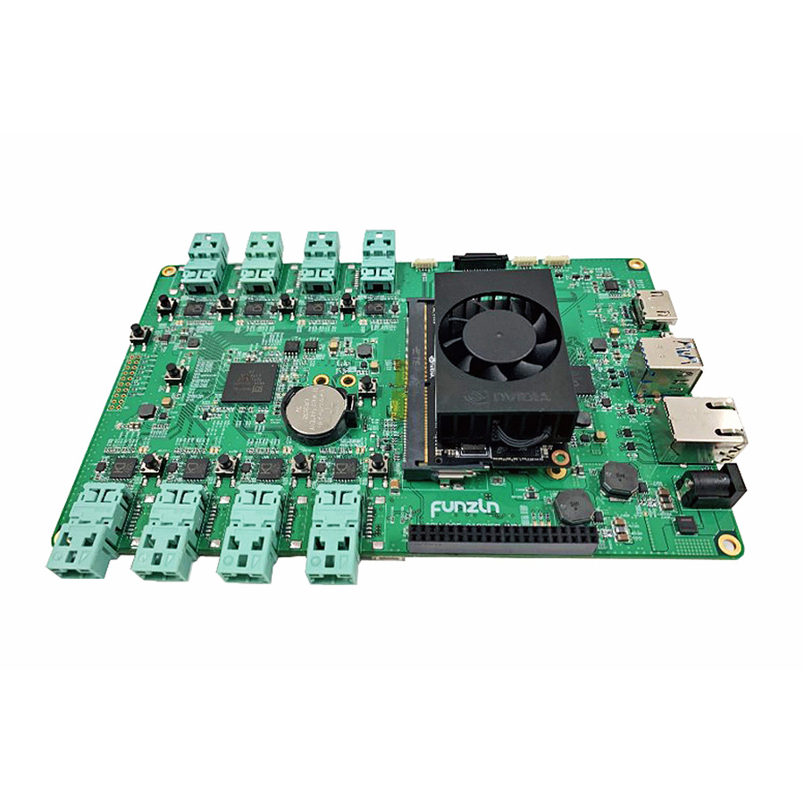 |  | Image 1: New Funzin AIoT Platform FAIP 3.0 and Edge AI Device Photon integrate KDPOF KD9351 and KD1053 for autonomous vehicles  Copyright: Funzin  Download: https://www.ahlendorf-news.com/media/news/images/Funzin-KDPOF-aiot-platform-faip30-H.jpg
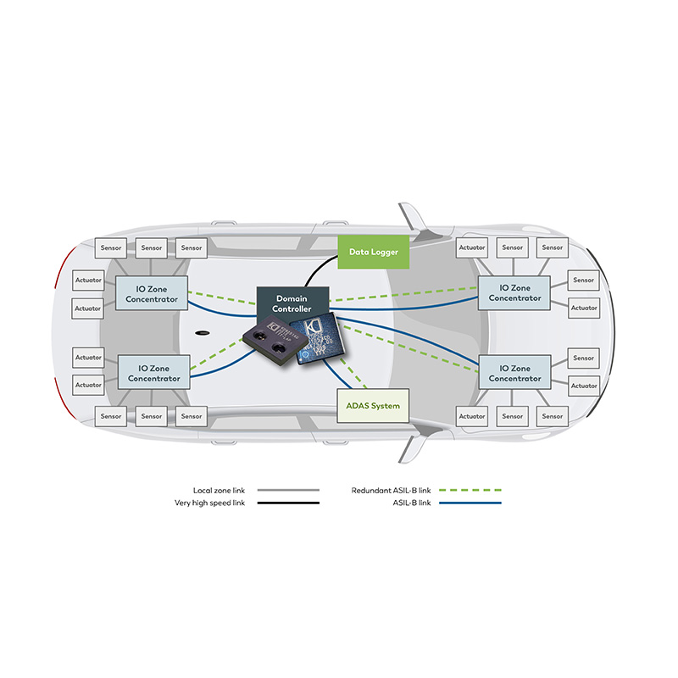 |  | Image 2: Efficient optical network with integrated KD9351 and KD1053 from KDPOF in vehicles  Copyright: KDPOF  Download: https://www.ahlendorf-news.com/media/news/images/KDPOF-KD9351-safe-backbone-H.jpg
Image 3: Ms. Deuk Hwa Kim is CEO/President of Funzin

Copyright: Funzin
Download: https://www.ahlendorf-news.com/media/news/images/Funzin-Deuk-Hwa-Kim-H.jpg
Image 4: Carlos Pardo is CEO and Co-founder of KDPOF

Copyright: KDPOF
Download: https://www.ahlendorf-news.com/media/news/images/KDPOF-Carlos-Pardo-H.jpg

About Funzin

Funzin is a software development and edge AI solution company based in South Korea. Since its foundation in 2006, Funzin has expanded its business areas to cover loT, T-commerce, telecommunication engineering, and smart car based on the interactive mobile telecommunication technologies including 3G and 4G. More information is available at https://funzin.co.kr.

Funzin Co. Ltd
EAST-13FL, Hyundai Terrace Tower, 7, Yeonmujang 5ga-gil
Seongdong-gu, Seoul, Republic of Korea
E funzin.ir@funzin.co.kr
T +82 2 929 9579 80

About KDPOF

Fabless semiconductor supplier KDPOF provides innovative high-speed optical networking for harsh environments. Making gigabit communications over fiber optics a reality, KDPOF technology supplies 1 Gb/s POF (plastic optical fiber) links for automotive, industrial, and home networks. Founded in 2010 in Madrid, Spain, KDPOF offers their cost-effective technology as either ASSP or IP (Intellectual Property) to be integrated in SoCs (System-on-Chips). The adaptive and efficient system works with a wide range of optoelectronics and low-cost large core optical fibers, thus delivering carmakers low risk, low cost and short time-to-market. More information is available at www.kdpof.com.

KDPOF Knowledge Development for POF, S.L.
Ronda de Poniente 14, 2ª Planta
28760 Tres Cantos, Spain
E pr@kdpof.com
T +34 918043387

Media Contact:
Mandy Ahlendorf
ahlendorf communication
E ma@ahlendorf-communication.com
T +49 89 41109402

