KDPOF Complements Renesas New Vehicle Computer VC4

1000BASE-RHC Optical Physical Layer Adds Robust and EMC-safe Network Interface to Communication Gateway ECU

Madrid (Spain) May 3, 2022 – KDPOF, leading supplier for gigabit connectivity over fiber optics, proudly announced that their well-proven KD1053 PHY IC and integrated KD9351 FOT (Fiber Optic Transceiver) have been implemented by Renesas, a premier supplier of advanced semiconductor solutions, into the new next generation automotive vehicle computer VC4. This comprehensive communication gateway ECU from Renesas features the newest automotive network technologies and sufficient computing power to host the ever-increasing number of user applications. “With the VC4, we have integrated an optical Ethernet interface into our automotive evaluation boards for the first time,” stated Tobias Belitz, Principal Engineer at Renesas. “KDPOF shared their 1000BASE-RH transceiver KD1053 and KD9351 FOT according to IEEE 802.3bv with us, which also covers the wide temperature range we are looking at.”

The four megatrends of autonomous driving, connected cars, electric vehicles, and shared mobility move the E/E architecture from domain based into a zonal architecture in order to meet the increasing complexity and computation demands of the next generation vehicles. With the VC4 communication gateway ECU, Renesas provides a universal development platform for automotive customers based on their R-Car-S4 system-on-module.

KDPOF Chipset for Safe Backbone and ADAS Sensor Connection

Optical connectivity perfectly solves the challenges posed by electrical interference in vehicles thanks to its low weight, low cost, and electromagnetic compatibility due to inherent galvanic isolation. “We are proud that Renesas has chosen our compact automotive Ethernet chipset for their future-ready vehicle computer VC4,” stated Carlos Pardo, CEO and co-founder of KDPOF. “With the integrated KD9351 FOT in combination with the KD1053 PHY IC, we deliver a complete automotive 1000BASE-RHC physical layer.“ Applications include safe Ethernet backbones, smart antenna modules, and sensor connections for ADAS and audio/video.

Incorporating the transmission and reception optoelectronics – such as transimpedance amplifier, photodiode, LED driver, and LED – into one single component, the KD9351 is an optical transceiver for 100 Mb/s up to 1 Gb/s with a small footprint. Additional benefits are a shorter supply chain and no test duplication with the final test at the Tier1. Furthermore, the assembly is simplified and the connector offers snap-fit without soldering. The KD9351 reuses low-cost MEMs encapsulation and allows SMD reflow assembly with 8 by 7 mm LGA components. It is fully shielded against electromagnetic radiation. The temperature range, from -40 °C to +105 °C, conforms with harsh automotive environmental requirements.

Presentation “Automotive Optical Ethernet Reaching for 50 Gb/s” at Automotive Ethernet Congress 2022

KDPOF will present latest highlights of their optical in-vehicle network technology at the Automotive Ethernet Congress from June 1 to 2, 2022 in Munich, Germany. On June 2 at 10:00 CEST, Carlos Pardo will give the presentation “Automotive Optical Ethernet Reaching for 50 Gb/s”.

Words: 467

More information
KDPOF Optical Ethernet: https://www.kdpof.com/automotive-networking/
Renesas VC4: https://www.renesas.com/us/en/blogs/renesas-next-generation-automotive-vehicle-computer-vc4-winning-combo-solution-r-car-ecosystem

Keywords: KDPOF, IEEE, fiber optics, KD1053, KD9351, multi-gigabit, automotive, automotive Ethernet, in-vehicle connectivity, automotive network, ADAS, autonomous vehicle, automated driving, connected vehicles, EMC, EMC-safe, photonics, Renesas, VC4, R-Car-S4, 1000BASE-RHC

Images

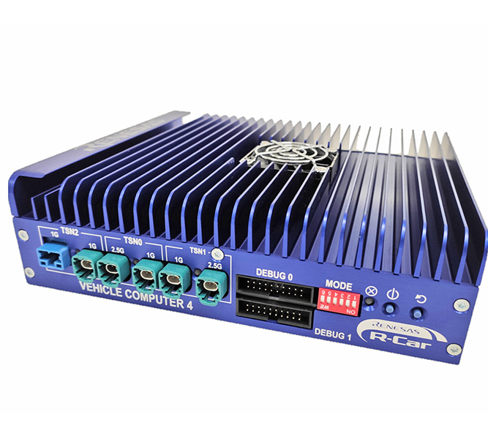 |  | Image 1: Renesas implements KDPOF’s 1000BASE-RHC optical physical layer in new vehicle computer VC4  Copyright: Renesas  Download: https://www.ahlendorf-news.com/media/news/images/KDPOF-inside-Renesas-vehicle-computer-vc4-H.jpg
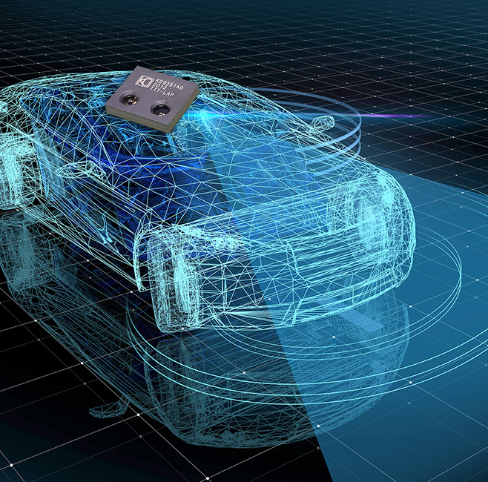 |  | Image 2: KDPOF equips Renesas’ VC4 with optical Ethernet for autonomous driving and connected cars  Copyright: KDPOF/Gettyimages  Download: https://www.ahlendorf-news.com/media/news/images/KDPOF-optical-ethernet-in-Renesas-vehicle-computer-vc4-H.jpg
Image 3: Tobias Belitz is Principal Engineer at Renesas

Copyright: Renesas
Download: https://www.ahlendorf-news.com/media/news/images/Renesas-Tobias-Belitz-H.jpg
Image 4: Carlos Pardo is CEO of KDPOF and active participant in the IEEE 802.3 working group

Copyright: KDPOF
Download: https://www.ahlendorf-news.com/media/news/images/KDPOF-Carlos-Pardo-H.jpg

About KDPOF

Fabless semiconductor supplier KDPOF provides innovative high-speed optical networking for harsh environments. Making gigabit communications over fiber optics a reality, KDPOF technology supplies 1 Gb/s POF (plastic optical fiber) links for automotive, industrial, and home networks. Founded in 2010 in Madrid, Spain, KDPOF offers their cost-effective technology as either ASSP or IP (Intellectual Property) to be integrated in SoCs (System-on-Chips). The adaptive and efficient system works with a wide range of optoelectronics and low-cost large core optical fibers, thus delivering carmakers low risk, low cost and short time-to-market. More information is available at www.kdpof.com.

KDPOF Knowledge Development for POF, S.L.
Ronda de Poniente 14, 2ª Planta
28760 Tres Cantos, Spain
E pr@kdpof.com
T +34 918043387

Media Contact:
Mandy Ahlendorf
ahlendorf communication
E ma@ahlendorf-communication.com
T +49 89 41109402

