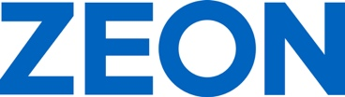

ZEON Europe GmbH
Hansaallee 249
40549 Düsseldorf
Germany
Phone +49-211-5267-0
Fax +49-211-5267-160
Email zeinfo@zeon.eu
Public Relations: Melanie Grape (ext. 131)

www.zeon.eu
P R E S S R E L E A S E

ZEON Introduces “Vision 2030” for Sustainability

Elastomer Innovations Serve Transformation of Automotive Industry Towards CO₂-neutral Mobility

Duesseldorf (Germany) June 27, 2022 – ZEON Europe GmbH – European subsidiary of ZEON Corporation, Japan, a leading and globally operating producer of specialty polymers – is proud to present their “Vision 2030” resulting in technology innovations in specialty elastomers, polymers, and specialty chemicals. “I am proud that at ZEON we make a considerable contribution to a sustainable planet and a safe and comfortable life with our technologies, products, and services,” stated Hubert Thimm, Commercial Director of ZEON Europe GmbH. “We see the greatest potential – but also challenges – for technical developments in the transformation of the automotive industry toward electrification of the powertrain and sustainable and CO₂-neutral mobility.”

Impact of the New Mobility on the Rubber Industry

The biggest challenges lie in the transformation of the automotive industry towards electrification, digitalization, and climate neutrality. “Raw material manufacturers have a central role to play here,” added Hubert Thimm. “According to our Vision 2030, we use the most sustainable raw materials possible in the development of new products.” In addition, ZEON is driving the decarbonization of existing products towards a circular economy.

The continuing trend towards e-mobility, with hybrid and battery electric vehicles, increasingly requires the use of tailored materials. In the area of conventional combustion engines, the focus remains on downsizing and reducing emissions. In order to comply with the increasing demands on polymer materials, ZEON has developed a series of new high-performance materials that stand out through improved resistance to new types of automotive operating fluids and media emerging with e-mobility.

ZEON will introduce their Vision 2030 and several new specialty rubber highlights from June 27 to 30, 2022 at the Deutsche Kautschuk Tagung (DKT; German Rubber Conference) and International Rubber Conference (IRC) in Nuremberg, Germany, at Stand 524 in Hall 9.

Words: 305

Keywords: ZEON, specialty rubber, DKT, Deutsche Kautschuk Tagung, IRC, International Rubber Conference, Vision 2030, CO2 footprint, sustainability, automotive, automotive industry, industrial, mobility, e-mobility, specialty elastomer, polymer, and specialty chemical, Hubert Thimm

Images

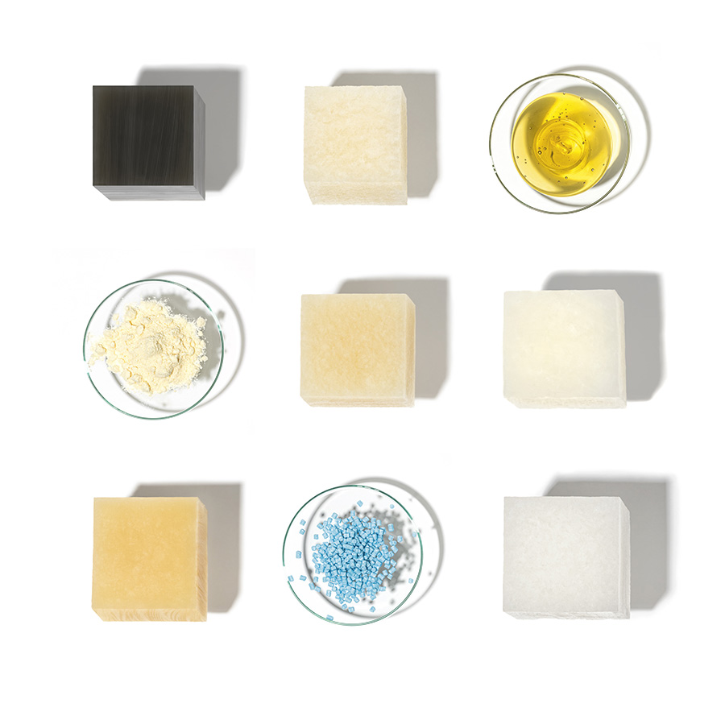 | Image 1: ZEON’s Vision 2030 results in technology innovations in specialty elastomers und polymers towards sustainability  Copyright: ZEON Europe GmbH  Download: https://www.ahlendorf-news.com/media/news/images/zeon-vision-2030-sustainability-mobility-1-H.jpg
Image 2: ZEON uses the most sustainable raw materials in new products and drives decarbonization

Copyright: SeanPavonePhoto - stock.adobe.com Download: https://www.ahlendorf-news.com/media/news/images/zeon-vision-2030-sustainability-mobility-2-H.jpg
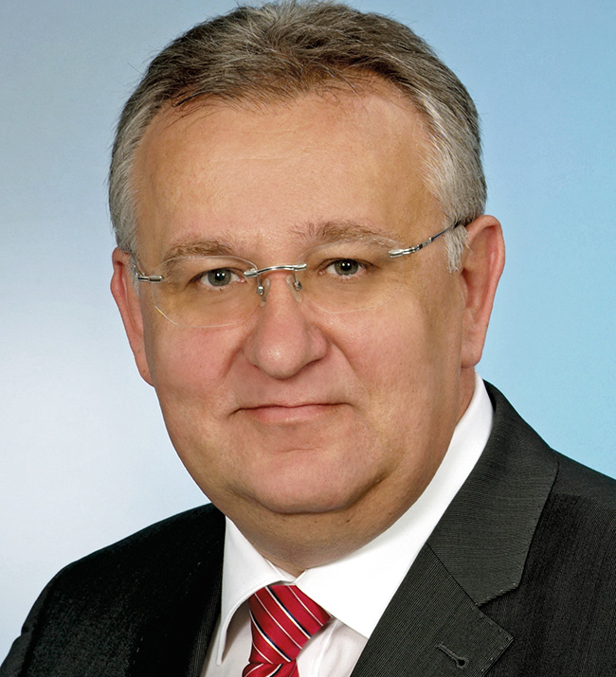 | Image 3: Hubert Thimm is Commercial Director of ZEON Europe GmbH  Copyright: ZEON Europe GmbH  Download: https://www.ahlendorf-news.com/media/news/images/Zeon-Hubert-Thimm-2-H.jpg

COMPANY PROFILE – ZEON Corporation is the world leader in specialty elastomers, polymers, and specialty chemicals. ZEON is one of the top producers of polymers in the world, operating a global network of plants in Asia and North America, and research and development laboratories in Japan, USA, China, and Singapore. With more than 70 years in business and consolidated sales of ca. US$ 3 billion, ZEON has both the experience and the expertise in C4 and C5 chemistry to offer a wide range of world class products. ZEON employs over 3,900 people worldwide, with global headquarters in Tokyo and regional sales offices all over Europe, America and Asia. “We realize the importance of having a close partnership with (potential) customers worldwide. Therefore, our resources in sales and technical service always put great effort into technical cooperation to bring positive momentum to our customers. Then, together we will find the optimum solution,” Hubert Thimm, ZEON Europe Commercial Director explained.

While ZEON is continuously settled in the traditional global elastomer business (60% of total business), the specialty material business has been progressively built up and has been growing significantly. ZEON specialty materials will provide material solutions for the future world in terms of sustainable energy sources, electromobility, digitalisation and media, as well as modern lifestyle and health care.

Media Contact

Melanie Grape
Zeon Europe GmbH
E-Mail: melanie.grape@zeon.eu
Phone: +49 (0)1738970420
Hansaallee 249
DE-40549 Düsseldorf

