KDPOF Designs First Optical 1000BASE-RH SFP Module

Test Houses Welcome New Small Form-factor Pluggable Transceiver Module for Evaluation of Optical Gigabit Ethernet in Vehicles

Madrid (Spain) July 27, 2022 – KDPOF, leading supplier for gigabit connectivity over fiber optics, has developed and validated the first 1000BASE-RH SFP module for optical gigabit connectivity in vehicles. The design of the new small form-factor pluggable transceiver module is based on a standard SFP supporting MSA registers via I²C bus. The module can operate at 100 and 1,000 Mb/s. It integrates the whole 1000BASE-RHC PHY and the header connector for SI-POF optical harness. “Our new SFP module has been tested and validated in a functional demo recently,” stated Carlos Pardo, CEO and Co-founder of KDPOF. “We are proud to accomplish the first milestone for future commercial optical 1000BASE-RH SFP modules, which will integrate into the optical ecosystem in automotive.”

Suds Rajagopal, Co-founder and Vice President of Aukua Systems, a leading provider of precision Ethernet & IP Test and Monitoring solutions, welcomes the new SFP from KDPOF: “As a test tool supplier for automotive Ethernet, we have been looking forward to this module. We are happy to integrate the optical 1000BASE-RH interfaces in our test equipment for evaluating KDPOF’s optical network design.”

The new SFP supports 1000BASE-X, 100BASE-X, and SGMII (with and without auto-negotiation) as electrical interfaces. It monitors the received optical power, the link margin, the junction temperature, and the supply voltages, among others.

The SFP design has been sampled and validated. Presently, KDPOF and Aukua are collaborating to optimize the 1000BASE-RHC SFP and make it available in the third quarter of 2022.

Words: 268

Keywords: KDPOF, IEEE, fiber optics, KD1053, KD9351, gigabit, automotive, automotive Ethernet, in-vehicle connectivity, automotive network, ADAS, autonomous vehicle, automated driving, connected vehicles, EMC, EMC-safe, photonics, SFP, 1000BASE-RH, small form-factor pluggable transceiver, Aukua Systems, MGA2510

Images

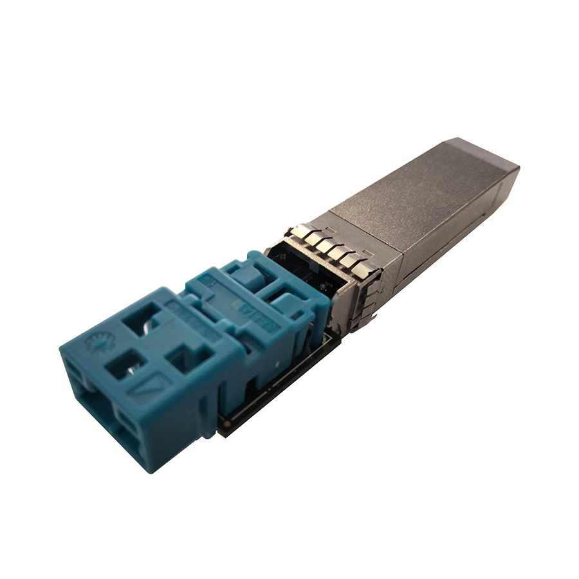 |  | Image 1: KDPOF has designed the first optical 1000BASE-RH SFP module for automotive Ethernet  Copyright: KDPOF  Download: https://www.ahlendorf-news.com/media/news/images/KDPOF-sfp-1000BASE-RH-1-H.jpg
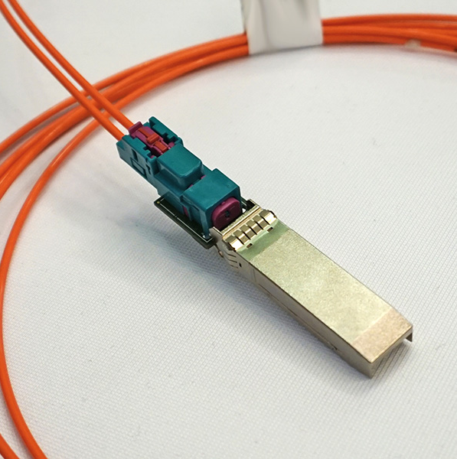 |  | Image 2: New SFP module from KDPOF operates at 100 and 1,000 Mb/s in automotive optical networks  Copyright: KDPOF  Download: https://www.ahlendorf-news.com/media/news/images/KDPOF-sfp-1000BASE-RH-2-H.jpg
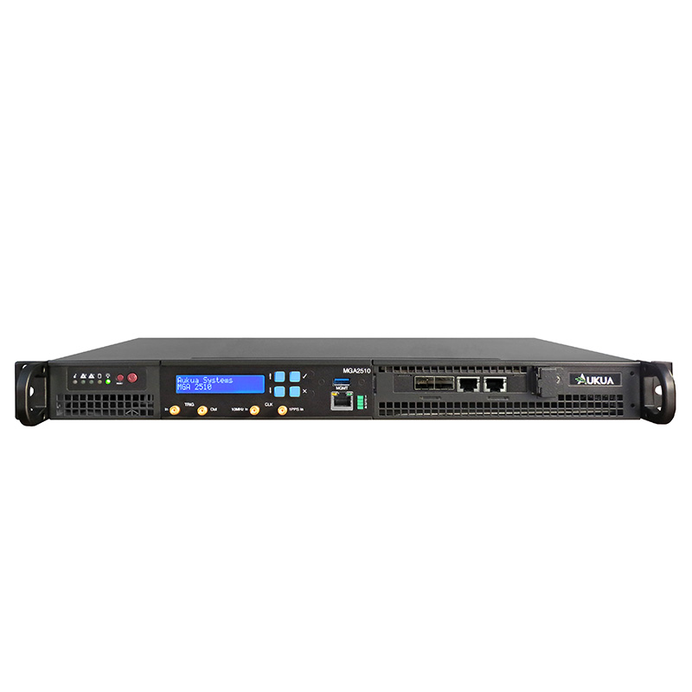 |  | Image 3: Aukua secures performance and reliability for automotive Ethernet with MGA2510 test and monitoring platform  Copyright: Aukua Systems  Download: https://www.ahlendorf-news.com/media/news/images/KDPOF-Aukua-mga2510-optical-automotive-ethernet-H.jpg
Image 4: Suds Rajagopal is Co-founder and Vice President of Aukua Systems

Copyright: Aukua Systems
Download: https://www.ahlendorf-news.com/media/news/images/Aukua-Systems-Suds-Rajagopal-H.jpg
Image 5: Carlos Pardo is CEO and Co-founder of KDPOF

Copyright: KDPOF
Download: https://www.ahlendorf-news.com/media/news/images/KDPOF-Pardo-Carlos-4-H.jpg

About KDPOF

Fabless semiconductor supplier KDPOF provides innovative high-speed optical networking for harsh environments. Making gigabit communications over fiber optics a reality, KDPOF technology supplies 1 Gb/s POF (plastic optical fiber) links for automotive, industrial, and home networks. Founded in 2010 in Madrid, Spain, KDPOF offers their cost-effective technology as either ASSP or IP (Intellectual Property) to be integrated in SoCs (System-on-Chips). The adaptive and efficient system works with a wide range of optoelectronics and low-cost large core optical fibers, thus delivering carmakers low risk, low cost and short time-to-market. More information is available at www.kdpof.com.

KDPOF Knowledge Development for POF, S.L.
Ronda de Poniente 14, 2ª Planta
28760 Tres Cantos, Spain
E pr@kdpof.com
T +34 918043387

Media Contact:
Mandy Ahlendorf
ahlendorf communication
E ma@ahlendorf-communication.com
T +49 89 41109402

