Zeon Expands Production Capacities

Production Increase of Retardation Film for LCD TVs and of High-Transparency Thermoplastic Cyclo Olefin Polymers (COP)

Duesseldorf (Germany) 26 October 2015 – Zeon Corporation - leading and globally operating specialty polymer company - has announced plans to further boost their production capacities. Zeon’s retardation film for LCD TVs ZeonorFilm™ will extend its production at its optical film plant in Himi City, Toyama Pref., Japan. "The facility will build a sixth production line, which follows the completion of the fifth line that began mass production in February of this year," said Hubert Thimm, Commercial Director of the Zeon Europe GmbH. "Once the sixth line becomes operational in January 2017, the plant’s total retardation film production capacity will increase by 24 million m2 to a total of 119 million m2 per year." In addition, Zeon has already started expanding the annual production capacity at the Mizushima Plant for ZEONEX® and ZEONOR® Cyclo Olefin Polymers (COP), a high-transparency thermoplastic resin, from 31,000 tons to 37,000 tons.

ZeonorFilm™: retardation film for LCD TVs

Retardation film is the key component of LCDs that enables a wide viewing angle (the anterior angle of the area in which images on a display appear normal) and contrast optimization, both of which are essential for LCD TV image quality. The demand for Zeon’s ZeonorFilm™ is increasing due to the excellent optical properties it possesses: high transparency, low birefringence, low wavelength dispersion, low photoelasticity, and outstanding dimensional stability owing to low water absorbency and heat resistance.

In recent years, the trend for increasingly larger size TVs and advances in high definition technology such as 4K TVs have continued to boost demand for Zeon’s ZeonorFilm™, which offers excellent optical properties and exceptional dimensional stability. Because the LCD TV market is forecast to remain on a steady growth path, Zeon will continue to meet the market’s demand with this period of capacity expansion.

ZEONEX® and ZEONOR®: Cyclo Olefin Polymers (COP)

For COP, with its product names ZEONEX® and ZEONOR®, Zeon has started expanding production capacity to meet the growing demand. Major applications are in markets such as printers, LCD televisions, smartphones, digital cameras, and primary pharmaceutical packaging. The decision is also due to the prospective business development of a new material based on Zeon’s proprietary molecular design. The expansion in production capacity is scheduled to be completed in April 2016.

ZEONEX® and ZEONOR® are fully amorphous and highly transparent thermoplastic resins. The balance of outstanding water barrier properties in combination with high purity, excellent chemical resistance, high transparency and no interaction with drugs place ZEONEX® and ZEONOR® as a perfect alternative to glass or other plastic solutions for vials, syringes and other customer-designed drug containers. Due to the non-polar, hydrophobic and non-reactive nature of the surface, there will be no interaction with the pharmaceutical drugs inside the prefilled container. ZEONEX® and ZEONOR® can be sterilized using steam autoclave, electron beam, gamma radiation and ethylene-oxide gas. Other handling benefits of ZEONEX® and ZEONOR® versus glass include their low specific weight and excellent shatter resistance. A recent development is the introduction of multilayer vials to market. These constructions combine the excellent water barrier of ZEONEX® and ZEONOR® with high oxygen barrier and additional mechanical strength from other polymers like polyamides. Another major benefit of plastic containers versus glass containers is the freedom of design.

Words: 551

Images
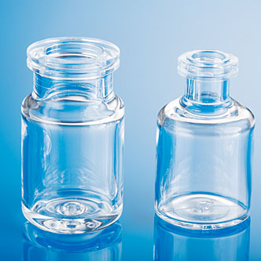 | Zeon announces production capacity increase of high-transparency Thermoplastic Cyclo Olefin Polymers (COP)
 | Copyright: Zeon
 | Download: http://www.ahlendorf-news.com/media/news/images/Zeon-COP-ZEONEX-ZEONOR-Flasche-H.jpg
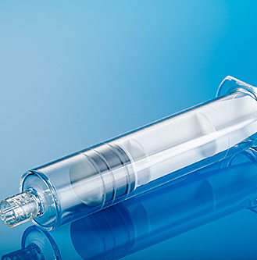 | ZEONEX® and ZEONOR® are fully amorphous and highly transparent thermoplastic resins for primary pharmaceutical packaging
 | Copyright: Zeon
 | Download: http://www.ahlendorf-news.com/media/news/images/Zeon-COP-ZEONEX-ZEONOR-Spritze-H.jpg
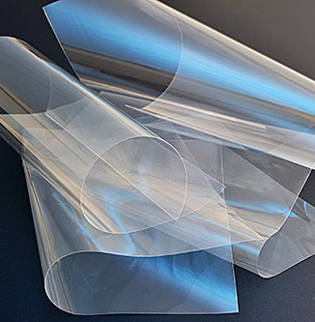 | The demand for Zeon’s ZeonorFilm™ is constantly increasing.
 | Copyright: Zeon
 | Download: http://www.ahlendorf-news.com/media/news/images/Zeon-COP-Zeonor-Film-H.jpg
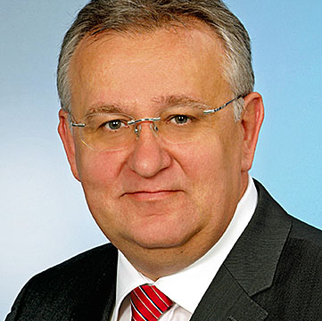 | Hubert Thimm is Commercial Director of Zeon Europe GmbH
 | Copyright: Zeon Europe GmbH
 | Download: http://www.ahlendorf-news.com/media/news/images/Zeon-Hubert-Thimm-H.jpg

About Zeon Europe GmbH

Zeon Europe GmbH is the European headquarter of Zeon Corporation and it is located in Duesseldorf, Germany. The globally leading specialty polymer company has more than 3,100 employees at 44 locations worldwide. The broad product portfolio of synthetic rubbers ranges from elastomers for tire applications up to heat and oil resistant specialty rubbers for different industry branches. There is a strong focus on the research and development of sustainable products. As acknowledged design partner, Zeon provides customer-specific solutions. The elastic polymers target many different industries such as automotive, aerospace, automation, oil and gas up to household technology and recreation. More information is available at www.zeon.eu.

Media Contact

Mandy Ahlendorf
ahlendorf communication
E-Mail: ma@ahlendorf-communication.com
Phone: +49 8151 9739098

Nathalie Langer
Zeon Europe GmbH
E-Mail: nathalie.langer@zeon.eu
Phone: +49 211 5267 127
Hansaallee 249
DE-40549 Düsseldorf

