Specialty Elastomers from ZEON for Printing and Paper Industries

drupa 2016: ZEON's Elastomers for Optimization of Material Properties

Duesseldorf (Germany) April 12, 2016 – ZEON – a leading and global-operating producer of specialty polymers - presents the novel portfolio of specialty elastomers for the printing and paper industries at drupa 2016, the number one international exhibition for printing and cross-media solutions. Worldwide, the printing and paper industries have been utilizing ZEON’s high temperature and chemicals resistant elastomers. Printing rollers, roller coverings, printing blankets, conveyer belts, machinery belts and gaskets are the typical final products. Starting from May 31st until June 10th, 2016, ZEON will show the latest elastomer developments at booth C92 in exhibition hall 3. Two examples to be named: Hydrin® T3108XL is an epichlorohydrin polymer that contributes to the improvement of the compound processability. Zeoforte® ZSC (ZEON Super Composite) is a material applicable for roller coverings with high hardness, high tensile strength, best abrasion resistance as well as superior dynamic properties. "The printing and paper industries acknowledge ZEON as an experienced and reputable elastomer development partner," explained Hubert Thimm, Commercial Director at ZEON Europe GmbH.

Development Partnership

As a partner in the field of elastomer materials for the printing and paper industries worldwide, ZEON supports all aspects of the product development, starting from polymer screening, compound development, tests and analysis, up to the optimization of the final products. Based on the long term experiences and the comprehensive expertise in the field of high performance elastomers, ZEON is continuously open for new partnerships and cooperation in the area of elastomer compound development in order to meet the most recent and challenging requirements of the paper and printing industries.

Words: 277

Images

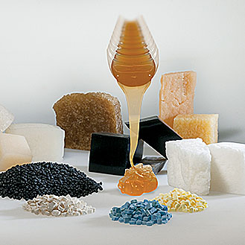 | ZEON is a recognized development partner of specialty elastomers and chemicals.
 | Copyright: Zeon Europe GmbH
 | Download: http://www.ahlendorf-news.com/media/news/images/Zeon-drupa-2016-H.jpg
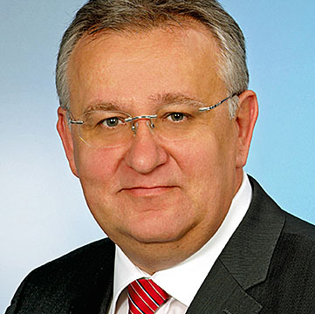 | Hubert Thimm is Commercial Director at ZEON Europe GmbH
 | Copyright: Zeon Europe GmbH
 | Download: http://www.ahlendorf-news.com/media/news/images/Zeon-Hubert-Thimm-H.jpg

About ZEON Europe GmbH

ZEON Europe GmbH is the European subsidiary of ZEON Corporation, located in Duesseldorf, Germany. The leading and global-operating specialty polymer company has currently more than 3,100 employees at 44 locations worldwide.

From elastomers for tire applications up to heat and oil resistant specialty elastomers for technical rubber articles cover the broad range of the elastomer product portfolio of ZEON.

ZEON is focusing on the research and development of sustainable polymer products for the future. As a recognized material development partner, ZEON is constantly working on specific solutions for the customers. The typical applications of ZEON’s elastomer materials can be found in versatile industry branches such as automotive/mobility, aerospace, building and construction, machinery, printing and paper as well as oil and gas. More information is available on the website at www.zeon.eu.

Media Contact

Mandy Ahlendorf
ahlendorf communication
E-Mail: ma@ahlendorf-communication.com
Phone: +49 8151 9739098

Svea Meuser
Zeon Europe GmbH
E-Mail: svea.meuser@zeon.eu
Phone: +49 211 5267 123
Hansaallee 249
DE-40549 Düsseldorf

