Automotive Gigabit Ethernet Put into Effect

KDPOF Announces Sampling of First Gigabit over POF Transceiver for Automotive Applications

Madrid, Spain, February 7, 2017 – KDPOF – leading supplier for automotive gigabit connectivity over POF (Plastic Optical Fiber) – announced the sampling of the first automotive Gigabit Ethernet POF (GEPOF) transceiver in 2017. "With the KDPOF KD1053, we are proud to introduce the first fully integrated automotive transceiver that implements the physical layer of Gigabit Ethernet over POF," stated Carlos Pardo, CEO and Co-Founder of KDPOF. "Optimized for low power and small footprint, it transmits data at 1000/100 Mbps on standard SI-POF, MC-POF, or PCS, according to 1000BASE-RH (IEEE 802.3bv)." The device perfectly meets the requirements of carmakers by providing high connectivity with flexible digital host interface, low latency, low jitter, and low linking time.

Simple and Flexible Integration of High Bandwidth

KDPOF designed the automotive KD1053 for use with automotive qualified photonics, including 650nm RCLED, LED, and Si PIN PD that are currently used in existing automotive products, with updated analog optoelectronics/interfaces. The KD1053 transceiver is flexible and makes integration simple by supporting different standards for the host digital interface. This simplifies the system and board level designs: RGMII, RMII, MII, SGMII, 1000BASE-X, and 100BASE-X. Also, it provides a Serial Management Interface (SMI). Manufacture is based on a 65-nm CMOS process for best performance, lowest cost, and lowest power for Plastic Optical Fiber (POF) solutions.

The KD1053 transceiver fulfills the requirements of the POF automotive market such as the key applications for future automotive networks: communication backbone, smart antenna link, infotainment, Battery Management Systems (BMS) and Advanced Driver Assistance Systems (ADAS). It is the perfect device to integrate high-speed capabilities in POF ports with a low-cost BOM (Bills Of Materials). Its built-in analog interface simplifies connectivity to Fiber Optic Transceivers (FOT). Examples of products able to incorporate POF ports based on the KD1053 ASSP include ECUs, switches, cameras, and infotainment nodes.

The first samples of the GEPOF KD1053 device will be available in August 2017.

Words: 332

Images

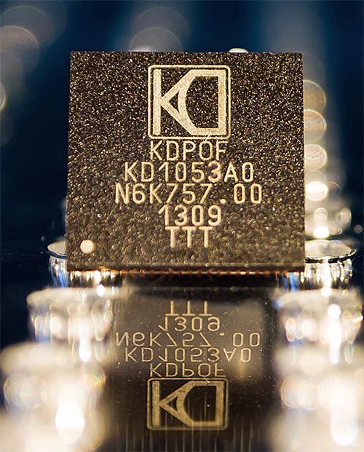 |  | Image 1: KDPOF starts sampling of the first automotive Gigabit Ethernet over POF (GEPOF) transceiver.  Copyright: KDPOF  Download: http://www.ahlendorf-news.com/media/news/images/KDPOF-GEPOF-KD1053-Sample-H.jpg
Image 2: Carlos Pardo is CEO and Co-Founder of KDPOF

Copyright: KDPOF
Download: http://www.ahlendorf-news.com/media/news/images/KDPOF-Carlos-Pardo-H.jpg

About KDPOF

Fabless semiconductor supplier KDPOF provides innovative gigabit and long-reach communications over Plastic Optical Fiber (POF). Making gigabit communication over POF a reality, KDPOF technology supplies 1 Gbps POF links for automotive, industrial, and home networks. Founded in 2010 in Madrid, Spain, KDPOF offer their technology as either ASIC or IP (Intellectual Property) to be integrated in SoCs (System-on-Chips). The adaptive and efficient system works with a wide range of optoelectronics and low-cost large core optical fibers, thus delivering carmakers low risks, costs and short time-to-market. More information is available at www.kdpof.com.

KDPOF Knowledge Development for POF, S.L.
Ronda de Poniente 14, 2ª Planta
28760 Tres Cantos
Spain
E support@kdpof.com
T +34 918043387

Media Contact:

Mandy Ahlendorf
ahlendorf communication
E ma@ahlendorf-communication.com
T +49 8151 9739098

