Optical Connections for Battery Management

Gigabit Ethernet POF by KDPOF Meets Requirements for Galvanic Isolation in Vehicles

Madrid, Spain, August 31, 2017 – KDPOF – leading supplier for automotive gigabit connectivity over POF (Plastic Optical Fiber) – now provide their plastic optical fiber connections for battery management systems (BMS) in vehicles. "Electric and hybrid power trains present different voltage domains with large level differences, such as the ECU domain with 12 Volts, the actuators domain with 48 Volts, and the electric power domain with 400 Volts," explained Carlos Pardo, CEO and Co-founder of KDPOF. "The galvanic isolation between these domains is a must due to ground parasitic resistance and potential shorts between voltage domains." Optical connections with POF provide the optimal means to achieve galvanic isolation, providing 100 Mbps Ethernet compatible solutions with enough margin to withstand the harsh automotive environment. In addition, they are easy to upgrade to 1000 Mbps when a higher data rate is required.

Galvanic Isolation

The lack of galvanic isolation between the domains of a battery management system causes a serious threat to the user and a source of severe damage to the electromechanical parts of the car. Galvanic isolation is also necessary between the primary and secondary systems of both ac-dc and dc-dc converters due to the presence of hazardous high voltage (above 25 Vac or 60 Vdc). According to the FMVSS 305 and ECE-R standards, the isolation barrier between battery and exposed conductive parts should maintain 500 Ω/V before and after a crash impact. "This is a tough requirement that is very hard to reach without a nearly perfect isolation that copper-based networks are unable to ensure," added Carlos Pardo.

A low cost and low performance means to achieve galvanic isolation is an opto couplers based solution, which is rather unreliable and offers very limited speed performance. Looking at optical connections, glass optical fiber (GOF) does not provide enough margin for automotive requirements. This solution is mainly aimed at the highly-controlled environment of data centers, and does not meet automotive norms. Consequently, the first choice for battery management systems is Gigabit Ethernet POF (GEPOF), which perfectly meets the requirements of carmakers by providing high connectivity with a flexible digital host interface, low latency, low jitter, and low linking time. KDPOF's transceiver for Ethernet over POF, the KD1053, is optimized for low power and small footprint and transmits data at 1000/100 Mbps on standard SI-POF, MC-POF, or PCS, according to 1000BASE-RH (IEEE 802.3bv).

Words: 406

Images

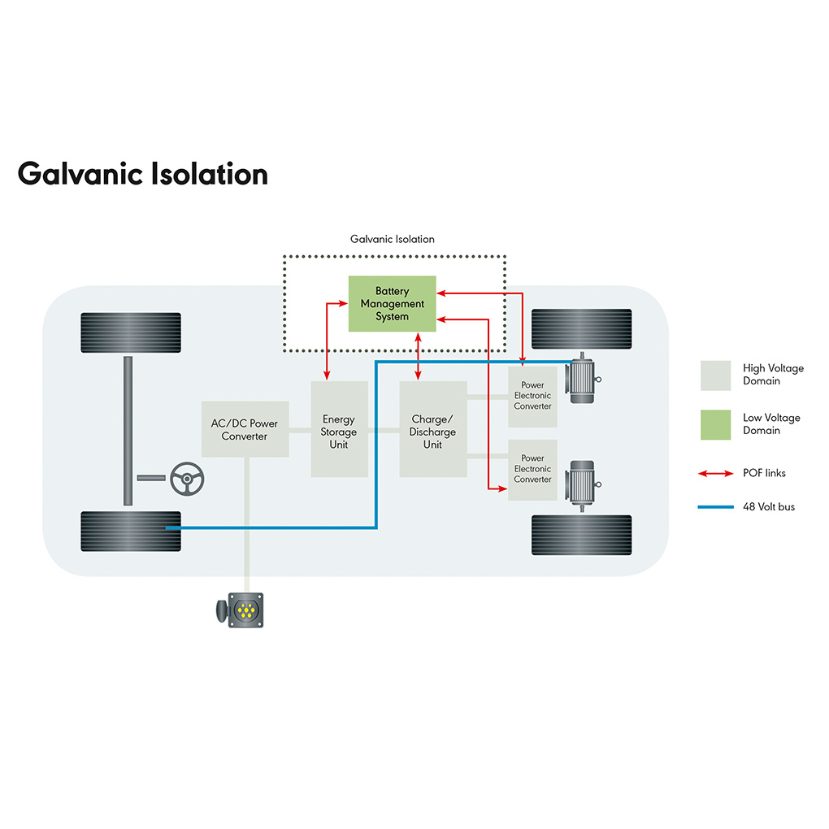 |  | Image 1: Optical connections with POF are ideal for galvanic isolation in battery management systems  Copyright: KDPOF  Download: http://www.ahlendorf-news.com/media/news/images/KDPOF-bms-galvanic-isolation-H.jpg
Image 2: Carlos Pardo is CEO and Co-Founder of KDPOF

Copyright: KDPOF
Download: http://www.ahlendorf-news.com/media/news/images/KDPOF-Carlos-Pardo-H.jpg

About KDPOF

Fabless semiconductor supplier KDPOF provides innovative gigabit and long-reach communications over Plastic Optical Fiber (POF). Making gigabit communication over POF a reality, KDPOF technology supplies 1 Gbps POF links for automotive, industrial, and home networks. Founded in 2010 in Madrid, Spain, KDPOF offers their technology as either ASSP or IP (Intellectual Property) to be integrated in SoCs (System-on-Chips). The adaptive and efficient system works with a wide range of optoelectronics and low-cost large core optical fibers, thus delivering carmakers low risks, costs and short time-to-market. More information is available at www.kdpof.com.

KDPOF Knowledge Development for POF, S.L.
Ronda de Poniente 14, 2ª Planta
28760 Tres Cantos
Spain
E support@kdpof.com
T +34 918043387

Media Contact:

Mandy Ahlendorf
ahlendorf communication
E ma@ahlendorf-communication.com
T +49 8151 9739098

