Embedded World 2019: ARIES Embedded Will Present New System-on-Module with PolarFire FPGA

M100PF Board Enhances and Optimizes Microchip's PolarFire FPGA for Industrial and Medical Technology

Fuerstenfeldbruck, Germany, 29 January 2019 – ARIES Embedded, specialist for embedded services and products, will display the new M100PF System-on-Module (SoM) based on Microchip's PolarFire FPGA (Field Programmable Gate Array) family at Embedded World from February 26 to 28, 2019 in Nuremburg, Germany. At stand 441 in hall 3A, the embedded specialist will also introduce the complementary evaluation platform M100PFEVP, which delivers a fast and easy project start for customers. "Our new M100PF board provides the full flexibility of the popular FPGAs for demanding applications in industrial and medical technology," stated Andreas Widder, Managing Director of ARIES Embedded. "PolarFire captivates with up to 50 percent lower power consumption than competing FPGAs, at mid-range densities with exceptional safety and reliability." With the SoM, ARIES Embedded extends the FPGA functionality with RAM, Flash, Clocking and additional features.

M100PF Flexibly and Reliably Serves Industrial Applications

For industrial use, the system-on-module allows an expanded temperature range, from 0° to +70°C up to -40° to +85°C. On the ARIES SoM, the PolarFire FPGAs provide 100k, 192k, or 300k logic elements (LE) and feature 12.7G transceivers with up to 50 percent lower power consumption. The 256 Mbit configuration storage, the DDR3 RAM (512 Mbit, 1 or 2 Gbit), as well as 4 to 64 Gbit eMMC NAND Flash allow the development of complex high performance designs. Further features of the 72 by 40 mm small SoMs are: 8 SerDes with 250 Mbps to 12.5 Gbps, 2 PCI express Gen2 end points/root port slots, rich user I/O, and 2 Samtec QSH-090-01-F-D-A board-to-board connectors.

Easy Project Start with Evaluation Board M100PFEVP

ARIES Embedded provides the corresponding evaluation platform M100PFEVP for a smooth and fast project start. It enables customers to evaluate the PolarFire FPGA, realize prototypes and even use the FPGA in series production. The evaluation board contains 2 gigabit Ethernet, USB, and 4 DSub9 interfaces for CAN, RS232, and others, in addition to Pmod and HSMC extension connectors and a microSD card slot. The M100PFEVP starter kit includes the M100PVEVP baseboard, M100PF-1DB storage extensions, a 7-inch touchscreen, and power supply.

Words: 367

Images

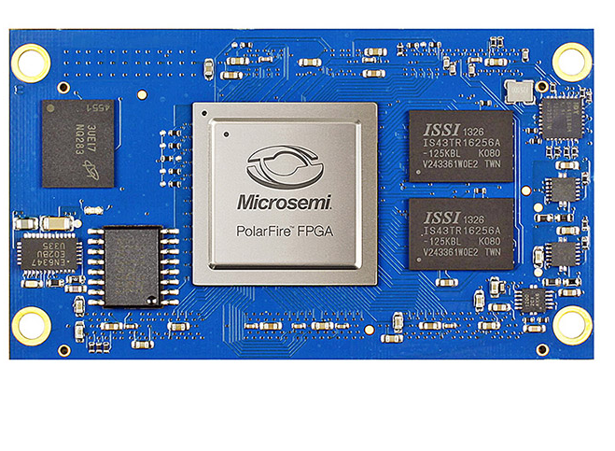 | Image 1: ARIES Embedded integrates Microchip's PolarFire FPGA in M100PF system-on-module for industrial and medical technology  Copyright: ARIES Embedded GmbH  Download: http://www.ahlendorf-news.com/media/news/images/aries-embedded-M100PF-PolarFire-SoM-H.jpg
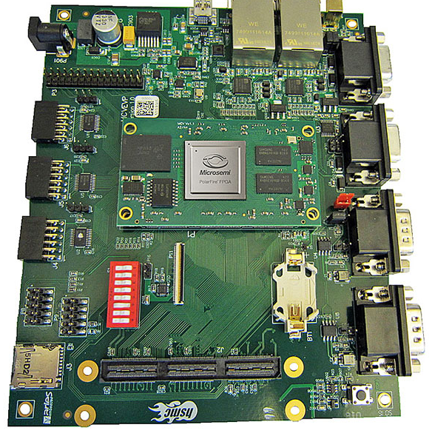 | Image 2: The M100PFEVP evaluation platform by ARIES Embedded provides a smooth and fast project start  Copyright: ARIES Embedded GmbH  Download: http://www.ahlendorf-news.com/media/news/images/aries-embedded-M100PFEVP-PolarFire-SoM-H.jpg
Image 3: Andreas Widder is Managing Director of ARIES Embedded GmbH

Copyright: ARIES Embedded GmbH
Download: http://www.ahlendorf-news.com/media/news/images/aries-embedded-Andreas-Widder-H.jpg

About ARIES Embedded
ARIES Embedded provides hardware and software development and standard products for industrial and agricultural sectors. The 2001 founded embedded specialist headquartered in Fuerstenfeldbruck, Germany, focuses on FPGA technology and open source software. The portfolio comprises of modular systems for flexible and fast use in functional prototypes, pilot series and mass production. On customer request, ARIES Embedded individually customizes standard products in accordance with project requirements. Further information is available at www.aries-embedded.com.

ARIES Embedded GmbH
Schöngeisinger Str. 84
DE-82256 Fuuerstenfeldbruck
Fon: +49 8141 36 367 0
Fax: +49 8141 36 367 67
www.aries-embedded.com
info@aries-embedded.de

Media Contact
Mandy Ahlendorf
ahlendorf communication
ma@ahlendorf-communication.com
+49 89 41109402

