Guaranteed Wi-Fi Mesh up to 1 Gigabit with Robust, Low Latency POF Backbone

KDPOF Field Study Proves Over 350% Better Performance for Wi-Fi with POF as Backbone for Home Networks

Madrid, Spain, April 10, 2019 – KDPOF – leading supplier for gigabit transceivers over POF (Plastic Optical Fiber) – boosts Wi-Fi performance to the next level for homes and small and home offices. "With our robust, low latency Plastic Optical Fiber, we provide the highest Wi-Fi mesh performance with a guaranteed 1 Gigabit per second to each access point," stated Carlos Pardo, CEO and Co-Founder of KDPOF. "Our field study with a tier one Service Provider proves that, in combination with Wi-Fi mesh nodes, the in-wall POF backbone raises performance throughout the house to over 350 percent in flats and up to 560 percent in multistory houses, compared with using a Wi-Fi backbone." Plastic Optical Fiber is cost-efficient, low skill to install, and robust. POF can reuse any existing conduits in the home, making the cables invisible. It is much easier and quicker to install than Cat 6 cables. In addition to being used as a backbone for home networking, POF provides convenient Optical Network Termination (ONT) to GW link for a better placement of the Gateway (GW) within the home. By working with KDPOF, operators can satisfy their clients by providing very low latency, reduced jitter, fast download speeds, and reliable connectivity for video.

Field Study Confirms Superiority of Combined POF/Wi-Fi Backbone

KDPOF has conducted the field study to compare Wi-Fi performance using the same additional Wi-Fi Mesh nodes in three different types of homes: single-family houses, multistory houses, and flats. One study group used a POF backbone and the other used a Wi-Fi backbone. Transmission speed was measured in three selected rooms in each case. The results were explicit and significant: averaged out of the 20 family test houses, the POF backbone brought about an improvement of more than 400 percent, while a pure Wi-Fi backbone had a limited performance of up to 80 Mbps in 50 percent of the houses. In the multistory houses, the POF backbone’s performance enhancement reached over 560 percent, whereas Wi-Fi only had a reduced output of up to 62 Mbps. Despite the limited number of Wi-Fi end points used in the test, the numbers provided by the Wi-Fi backbone fall far short of the access speeds users have started to enjoy up to their homes. By using the same Wi-Fi Mesh nodes with a POF backbone, the end user experience achieves those numbers. End users experience what they pay for.

Another important result was that with only one more access point with POF as the backbone, performance is significantly better sustained than with two additional access points with a Wi-Fi backbone. POF Backbone simplifies the Wi-Fi mesh architecture and reduces costs while improving overall performance substantially.

KDPOF will present their robust in-wall optical connectivity at stand 3 at Broadband Forum Asia on May 7-8, 2019 in Bangkok, Thailand. In his presentation "Bringing WiFi Performance to the Next Level" on 7 May at 12:20, Ramón Garcia, Business Development Manager with KDPOF, will explain options and good practices for how to transform access speeds into Wi-Fi speeds for a Gigabit experience.

Words: 534

Images

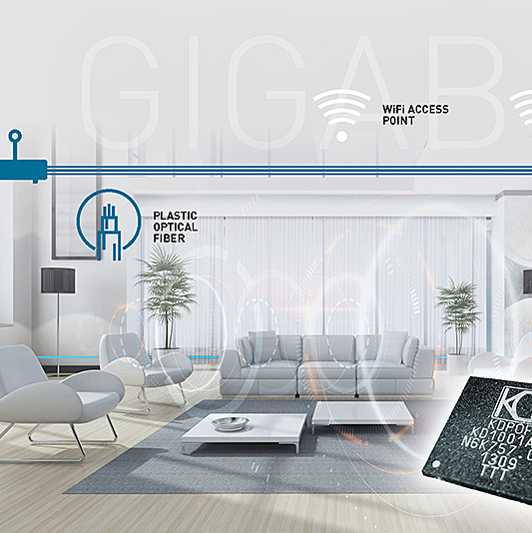 |  | Image 1: KDPOF robust, low latency POF backbone provides guaranteed Gigabit Wi-Fi mesh  Copyright: KDPOF  Download: http://www.ahlendorf-news.com/media/news/images/KDPOF-home-net-wifi-gigabit-H.jpg
Image 2: Carlos Pardo is CEO and Co-Founder of KDPOF

Copyright: KDPOF
Download: http://www.ahlendorf-news.com/media/news/images/KDPOF-Carlos-Pardo-H.jpg

About KDPOF

Fabless semiconductor supplier KDPOF provides innovative gigabit and long-reach communications over Plastic Optical Fiber (POF). Making gigabit communication over POF a reality, KDPOF technology supplies 1 Gbps POF links for automotive, industrial, and home networks. Founded in 2010 in Madrid, Spain, KDPOF offers their technology as either ASSP or IP (Intellectual Property) to be integrated in SoCs (System-on-Chips). The adaptive and efficient system works with a wide range of optoelectronics and low-cost large core optical fibers, thus delivering customers low risks, costs and short time-to-market. More information is available at www.kdpof.com.

KDPOF Knowledge Development for POF, S.L.
Ronda de Poniente 14, 2ª Planta
28760 Tres Cantos, Spain
E support@kdpof.com
T +34 918043387

Media Contact:
Mandy Ahlendorf
ahlendorf communication
E ma@ahlendorf-communication.com
T +49 89 41109402

