New System-on-Module M100PFS Based on Microchip’s Low-power PolarFire SoC FPGA

Embedded World 2020: ARIES Embedded Integrates Industry’s First Multi-Core RISC-V System-on-Chip FPGA

Fuerstenfeldbruck, Germany, January 29, 2020 – ARIES Embedded, specialist in embedded services and products, will present their brand-new System-on-Module (SoM) M100PFS at Embedded World 2020, stand 441 in hall 3A from February 25 to 27, 2020 in Nuremberg, Germany. The M100PFS SoM is based on the PolarFire® SoC, the System-on-Chip (SoC) FPGA family from Microchip that combines a high-performance 64-bit RISC-V multicore processor subsystem with low-power FPGA technology.

“Our new platform enables customers to easily take advantage of the PolarFire SoC’s hardened real-time, Linux capable, RISC-V processor subsystem integrated with the PolarFire FPGA family, the industry’s lowest-power, mid-range FPGAs,” stated Andreas Widder, Managing Director of ARIES Embedded. “Applications can benefit from the low power consumption, thermal efficiency, and defense-grade security for a range of embedded systems that require deterministic operation.”

The new M100PFS FPGA SoM is ideally suited for secure, power-efficient computation in a wide range of applications including Smart Embedded Vision, Industrial Automation, Communications, and Industrial Internet of Things.

Low Power, Reliable, Secure

The 74 by 42 mm small M100PFS SoM runs with low device static power, low inrush current and low-power transceivers. The PolarFire FPGA technology stands out for its reliability with single-event upset (SEU) immunity, built-in SECDED and LSRAM memory interleaving built into the FPGA fabric. In addition, SECDED runs on all processor memory resources and the system controller suspend mode serves safety-critical designs. Several features support security aspects: for example, Cryptography Research Incorporated (CRI)-patented differential power analysis (DPA) bit stream protection, integrated dual physically unclonable function (PUF), and 56 KB of secure, non-volatile memory (sNVM).

Powerful and Versatile

The PolarFire SoC onboard the M100PFS SoM from ARIES Embedded combines a Quad 64-bit RISC-V 64GC core and a 64-bit RISC-V 64 IMAC monitor core. The SoM uses the FCVG484 package that scales from the PolarFire SoC’s 23k logic element (LE) device up to the 250k LE device. A SoM offering the largest 460k LE PolarFire SoC device will be offered in later versions. The RISC-V CPU micro-architecture implementation is a simple 5-stage, single issue, in-order pipeline that is immune to the Meltdown and Spectre exploits found in common out-of-order machines.

All five CPU cores are coherent, with the memory subsystem allowing a versatile mix of deterministic real-time systems and Linux in a single multi-core CPU cluster. Processor I/Os include: 2x Gigabit Ethernet, USB 2.0 OTG, 2x CAN 2.0 A and B, Execute in place Quad SPI flash controller, 5x multi-mode UARTs, 2x SPI, 2 I²C, RTC, GPIO, and 5x watchdog timers. Memory comprises 1/2/4 GByte LPDDR4 RAM dedicated to the HMS, 1/2/4 GByte LPDDR4 RAM dedicated to the FPGA, 32 Mbit NOR Flash, and 4 - 64 GByte eMMC memory. The default configuration contains Gigabit Ethernet, UART, CAN, SPI, I²C, and USB.

ARIES Embedded will introduce a first prototype of the M100PFS SoM at Embedded World trade show at stand 441 in hall 3A from February 25 to 27, 2020 in Nuremberg, Germany, and will start shipping boards to customers in the fourth quarter of 2020.

Words: 520

Further information:
https://www.aries-embedded.com/polarfire-soc-fpga-microsemi-m100pfs-som-mpfs025t-pcie-serdes
https://www.microsemi.com/product-directory/soc-fpgas/5498-polarfire-soc-fpga

Images

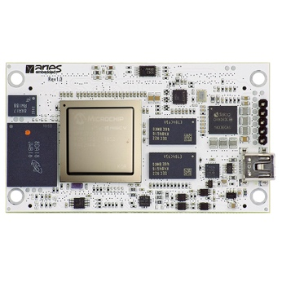 | Image 1: ARIES Embedded presents new System-on-Module M100PFS based on Microchip’s PolarFire SoC FPGA  Copyright: ARIES Embedded GmbH  Download: http://www.ahlendorf-news.com/media/news/images/aries-embedded-M100PFS-som-polarfire-soc-FPGA-H.jpg
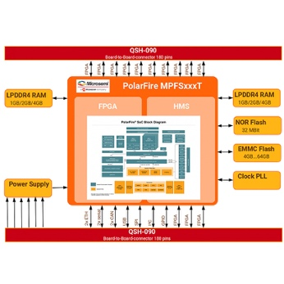 | Image 2: The new M100PFS FPGA SoM is ideally suited for secure, power-efficient computation in a wide range of industrial applications.  Copyright: ARIES Embedded GmbH  Download: http://www.ahlendorf-news.com/media/news/images/aries-embedded-M100PFS-som-polarfire-soc-FPGA-blockdiagram-H.jpg
Image 3: Andreas Widder is Managing Director of ARIES Embedded GmbH

Copyright: ARIES Embedded GmbH
Download: http://www.ahlendorf-news.com/media/news/images/aries-embedded-Andreas-Widder-H.jpg

About ARIES Embedded
ARIES Embedded provides hardware and software development and standard products for industrial and agricultural sectors. The 2001 founded embedded specialist headquartered in Fuerstenfeldbruck, Germany, focuses on FPGA technology and open source software. The portfolio comprises of modular systems for flexible and fast use in functional prototypes, pilot series and mass production. On customer request, ARIES Embedded individually customizes standard products in accordance with project requirements. Further information is available at www.aries-embedded.com.

ARIES Embedded GmbH
Schöngeisinger Str. 84
DE-82256 Fürstenfeldbruck
Fon: +49 8141 36 367 0
Fax: +49 8141 36 367 67
www.aries-embedded.com
info@aries-embedded.de

Media Contact
Mandy Ahlendorf
ahlendorf communication
ma@ahlendorf-communication.com
+49 89 41109402

