Automotive Ethernet Tester for Highly-automated Testing

Universal Test System by RUETZ SYSTEM SOLUTIONS for TC8 Switching and AVB/TSN Standards

Munich, Germany, February 10, 2020 - RUETZ SYSTEM SOLUTIONS - experts in automotive data communications - presents the new Automotive Ethernet Tester (AET), a highly-automated test system for OPEN ALLIANCE TC8 switching and AVB/TSN tests at the component level. "The Automotive Ethernet Tester is the consistent further development of our own test platform to equip vehicle manufacturers and suppliers with the best possible test setup," explained Wolfgang Malek, General Manager and Co-founder of RUETZ SYSTEM SOLUTIONS. "Whereas our well-proven Ethernet Live Monitor purely serves the intelligent and efficient error analysis of Ethernet data traffic, the Automotive Ethernet Tester generates different traffic and speed grades and records them, including the appropriate capture device." The test suites contain different test cases as the basis for the respective test scopes. Currently available are test suites for OPEN ALLIANCE TC8 switching, Automotive gPTP, 1722, and QAV. Test suites for QBV and other TSN functions are under development.

Universal, Highly-automated, Comprehensive

The test cases are script-based and parameterized prior to a test run via a single configuration file that contains all relevant properties of the device under test (DUT). The DUT and the test cases can be simply configured via easy-to-understand application interfaces. Users can easily select the individual test cases from a constantly growing database and assemble them into a new test run by drag-and-drop. The AET automatically saves the recorded data in a predefined folder structure. In addition, the test system includes an infrastructure for the complete recording of sent and received data. RUETZ SYSTEM SOLUTIONS provides an additional AET analyzer tool for analysis. It accesses the file structure and generates a result log from the recorded data. By separating the test and analysis systems, both systems can be used productively and efficiently in parallel.

The Automotive Ethernet Tester consists of a 19-inch test rack with control and analysis software. A PC control unit regulates the test system. Depending on the implementation, the test platform can contain up to 15 Ethernet ports (100BASE-T1, 1000BASE-T1), each of which can simulate and evaluate specific test scenarios. The test platform provides a display and PPS output for precise evaluation of the gPTP synchronization, as well as a display for the port status. It also controls the power supply for the DUT.

RUETZ SYSTEM SOLUTIONS will present the Automotive Ethernet Tester for the first time at booth 3C at the Automotive Ethernet Congress from February 12 to 13, 2020 in Munich, Germany. In his presentation, "AVB/TSN Testing Strategy from Semiconductor up to ECU and System Level,” on 13 February at 10:00 a.m., Martin Heinzinger from RUETZ SYSTEM SOLUTIONS will explain another test system.

Words: 455

Images
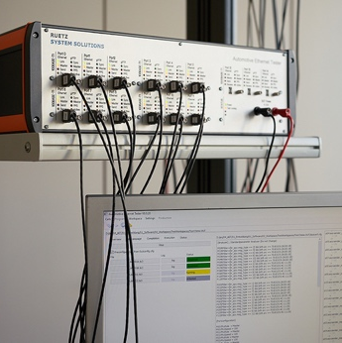 | Image 1: The Automotive Ethernet Tester (AET) is a highly-automated test system for TC8 switching and AVB/TSN tests  Copyright: RUETZ SYSTEM SOLUTIONS  Download: http://www.ruetz-system-solutions.com/uploads/RUETZ-SYSTEM-SOLUTIONS-Automotive-Ethernet-Tester-1-H.jpg
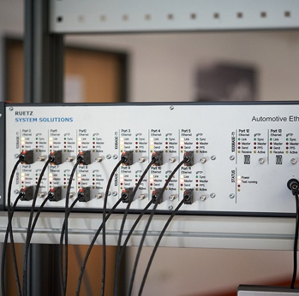 | Image 2: The Automotive Ethernet Tester generates different traffic and speed grades and records them  Copyright: RUETZ SYSTEM SOLUTIONS  Download: http://www.ruetz-system-solutions.com/uploads/RUETZ-SYSTEM-SOLUTIONS-Automotive-Ethernet-Tester-2-H.jpg
Image 3: Wolfgang Malek is General Manager and Co-Founder of RUETZ SYSTEM SOLUTIONS

Copyright: RUETZ SYSTEM SOLUTIONS
Download: http://www.ruetz-system-solutions.com/uploads/RUETZ-SYSTEM-SOLUTIONS-Wolfgang-Malek.jpg

RUETZ SYSTEM SOLUTIONS

With comprehensive expertise in data communication for automotive electronic systems, RUETZ SYSTEM SOLUTIONS provides full service to carmakers and suppliers for a smooth and timely production start (SOP). The technology partner based in Munich offers engineering services for system specification and integration, compliance tests, technology assessment, and training. Part of the test laboratory solutions are test systems and platforms. With broad competency in data bus systems for all in-car data transmission standards such as, amongst others, AVB, Bluetooth, CAN, Automotive Ethernet, FlexRay, LIN, MOST, USB, and WLAN are supported competently and reliably by the general contractor. More information is available at www.ruetz-system-solutions.com.

RUETZ SYSTEM SOLUTIONS GmbH
Oskar-Schlemmer-Strasse 13
80807 Munich, Germany

Media Contact:
ahlendorf communication
Mandy Ahlendorf
T +49 89 41109402
E ma@ahlendorf-communication.com

