ARIES Embedded Will Present Embedded Vision Kit "C-Vision" at Embedded World

Design Platform for Artificial Intelligence and Industrial Embedded Vision Integrates Cyclone V SoC-FPGA and Basler Dart Cameras

Fuerstenfeldbruck, Germany, February 4, 2020 – ARIES Embedded, specialist in embedded services and products, will present its new "C-Vision-Kit" for the first time at Embedded World International trade show at stand 441 in hall 3A in Nuremberg, Germany, from February 25 to 27, 2020. "With the new C-Vision-Kit, we provide a design platform for industrial applications with embedded vision and artificial intelligence (AI)", explained Andreas Widder, Managing Director of ARIES Embedded. "The combination of computer vision and AI in one kit enables the immediate processing and evaluation of image data." For the C-Vision-Kit, the embedded specialist has added two Basler dart cameras, an adapter board, and an AI accelerator board to the proven MCVEVP FPGA development board.

Simple and Affordable FPGAs Offer High Flexibility

ARIES Embedded has chosen the Cyclone V SoC-FPGA for the C-Vision-Kit because the ARM architecture with defined resources can also be used in a decentralized manner. "Many AI applications run on rather power-hungry x86 architectures that are expensive, complex, and not universally applicable with high power dissipation," added Andreas Widder. The FPGA also offers great flexibility to connect and control many different sensors and actuators. These include optical line, position, orientation, and acceleration sensors, AD converters, cameras, and more.

The core of the C-Vision-Kit is the MCV System-on-Module (SoM) on the MCVEVP baseboard, which can be optionally expanded with a 7-inch TFT display and capacitive touch screen. The C-Vision adapter can be used to connect two Basler Dart LVDS cameras, a miniPCIe card with Movidius Myriad X chip, Intel's Vision Processing Unit (VPU), and a monitor via an HDMI slot.

Words: 291

Further information:
https://www.aries-embedded.com/evaluation-kit/vision/c-vision
Images

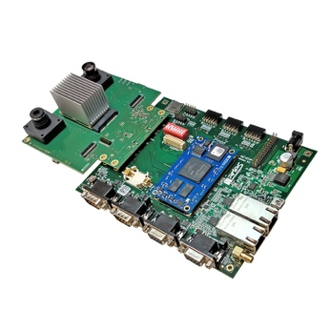 | Image 1: Embedded vision kit "C-Vision" from ARIES Embedded for artificial intelligence and industrial embedded vision  Copyright: ARIES Embedded GmbH  Download: http://www.ahlendorf-news.com/media/news/images/aries-embedded-c-vision-mcvevp-fpga-H.jpg
Image 2: Andreas Widder is Managing Director of ARIES Embedded GmbH

Copyright: ARIES Embedded GmbH
Download: http://www.ahlendorf-news.com/media/news/images/aries-embedded-Andreas-Widder-H.jpg

About ARIES Embedded

ARIES Embedded provides hardware and software development and standard products for industrial and agricultural sectors. The 2001 founded embedded specialist headquartered in Fuerstenfeldbruck, Germany, focuses on FPGA technology and open source software. The portfolio comprises of modular systems for flexible and fast use in functional prototypes, pilot series and mass production. On customer request, ARIES Embedded individually customizes standard products in accordance with project requirements. Further information is available at www.aries-embedded.com.

ARIES Embedded GmbH
Schöngeisinger Str. 84
DE-82256 Fürstenfeldbruck
Fon: +49 8141 36 367 0
Fax: +49 8141 36 367 67
www.aries-embedded.com
info@aries-embedded.de

Media Contact
Mandy Ahlendorf
ahlendorf communication
ma@ahlendorf-communication.com
+49 89 41109402

