ISO 21111 Complements IEEE Std 802.3bv™ for Overall Standardization of Optical Gigabit Connectivity

KDPOF Supports Complete, Compatible and Interoperating Implementation of Automotive Networks with 1 Gigabit per Second

Madrid, Spain, July 29, 2020 – KDPOF, leading supplier for gigabit transceivers over POF (Plastic Optical Fiber), welcomes the publication of two additional standards in the frame of the international in-vehicle Ethernet ISO standard series 21111. The supplementary parts, ISO 21111-3:2020 and ISO 21111-5:2020, specify further features for in-vehicle data transmission of 1 Gigabit per second over POF technology. “With the new ISO 21111 sections complementing the existing IEEE Std 802.3bvTM, optical Gigabit connectivity is now entirely standardized,” explained Carlos Pardo, CEO and Co-founder of KDPOF. “Based on these standards, our optical technology allows a complete, compatible, and interoperating implementation for carmakers and Tier1s.”

Publication of ISO 21111

ISO (International Organization for Standardization) has added two new sections to the in-vehicle Ethernet series 21111. These newly approved parts are key components to assure reliable implementations of systems that realize in-vehicle Ethernet Optical 1 Gb/s as a physical layer.

ISO 21111-3:2020 specifies additional features to IEEE 802.3bv, such as wake-up and synchronized link sleep algorithms. It also contains a complete conformance test plan for IC providers that implement this standard.

ISO 21111-5:2020 specifies requirements at the system level and a complete conformance and interoperability test plan for ECU providers that implement optical 1 Gb/s physical layer as specified in ISO 21111-3.

Further relevant parts of ISO 21111 for this type of high speed in-vehicle communications include:
- ISO 21111-1 provides general definitions.
- ISO 21111-2 defines general wake-up and sleep definitions and RGMII specifications.
- ISO 21111-4:2020 is devoted to optical connectivity component specification and tests.

Words: 279

Further information

ISO 21111-3:2020: https://www.iso.org/standard/70297.html
ISO 21111-5:2020: https://www.iso.org/standard/74728.html

ISO 21111-1: https://www.iso.org/standard/69923.html
ISO 21111-2: https://www.iso.org/standard/70621.html
ISO 21111-4:2020: https://www.iso.org/standard/71937.html

Images

Image 1: ISO 21111 complements IEEE Std 802.3bv™ for overall standardization of optical gigabit connectivity

Copyright: KDPOF
Download: https://www.ahlendorf-news.com/media/news/images/KDPOF-ISO-21111-optical-gigabit-ethernet-H.jpg
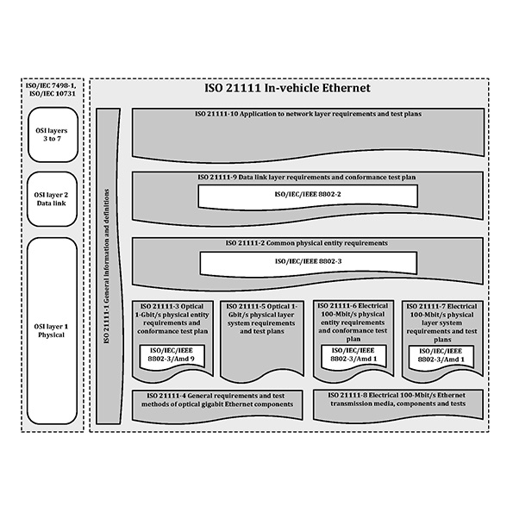 |  | Image 2: In-vehicle Ethernet document reference according to the OSI model  Copyright: ISO  Download: https://www.ahlendorf-news.com/media/news/images/KDPOF-ISO-21111-optical-gigabit-ethernet-osi-model-H.jpg
Image 3: Carlos Pardo is CEO and Co-Founder of KDPOF

Copyright: KDPOF
Download: https://www.ahlendorf-news.com/media/news/images/KDPOF-Carlos-Pardo-H.jpg

About KDPOF

Fabless semiconductor supplier KDPOF provides innovative gigabit and long-reach communications over Plastic Optical Fiber (POF). Making gigabit communications over POF a reality, KDPOF technology supplies 1 Gb/s POF links for automotive, industrial, and home networks. Founded in 2010 in Madrid, Spain, KDPOF offers their technology as either ASSP or IP (Intellectual Property) to be integrated in SoCs (System-on-Chips). The adaptive and efficient system works with a wide range of optoelectronics and low-cost large core optical fibers, thus delivering carmakers low risks, costs and short time-to-market. More information is available at www.kdpof.com.

KDPOF Knowledge Development for POF, S.L.
Ronda de Poniente 14, 2ª Planta
28760 Tres Cantos, Spain
E pr@kdpof.com
T +34 918043387

Media Contact:
Mandy Ahlendorf
ahlendorf communication
E ma@ahlendorf-communication.com
T +49 89 41109402

