Aukua Systems and KDPOF Team up for ISO 21111 Standardization

Successful Technology Partnership Results in ISO Standard for Optical In-Vehicle Gigabit Connectivity

Madrid (Spain) and Austin (Texas, USA), August 25, 2020 – Aukua Systems Inc., provider of Ethernet test and monitoring solutions, and KDPOF, leading supplier for gigabit transceivers over POF (Plastic Optical Fiber), are proud to announce the success of their technology partnership for ISO 21111 standardization. Recently, two additional sections, ISO 21111-3:2020 and ISO 21111-5:2020, of the international in-vehicle Ethernet ISO standard series 21111 have been published. “By providing their MGA2510 Ethernet Test and Monitoring Platform, Aukua Systems have supremely equipped the test setup for ISO certification,” stated Carlos Pardo, CEO and Co-founder of KDPOF. KDPOF supports the test ecosystem to make sure that ECUs including their technology will be tested by recognized test houses and based on the ISO standard. “We are delighted to support the overall standard for optical gigabit connectivity in vehicles with ISO 21111 complementing the existing IEEE Std 802.3bvTM,” added Suds Rajagopal, Co-Founder at Aukua Systems. “By leveraging Aukua’s test solutions, carmakers and Tier1s now have access to a complete, compatible, and interoperating implementation based on these standards.”

ISO 21111 Standardization

For reliable implementations of systems that implement in-vehicle Ethernet Optical 1 Gb/s as a physical layer, International Organization for Standardization (ISO) has added two new sections to the in-vehicle Ethernet series 21111: ISO 21111-3:2020 specifies additional features to IEEE 802.3bv, such as wake-up and synchronized link sleep algorithms. ISO 21111-5:2020 specifies requirements at the system level and a complete conformance and interoperability test plan for ECU providers that implement optical 1 Gb/s physical layer as specified in ISO 21111-3.

Words: 276

Images

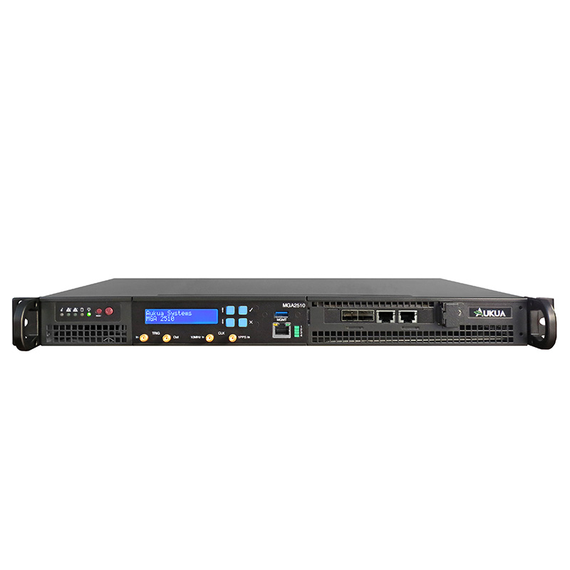 |  | Image 1: Technology partnership of Aukua Systems and KDPOF for ISO 21111 standardization  Copyright: Aukua Systems  Download: https://www.ahlendorf-news.com/media/news/images/KDPOF-Aukua-ISO-21111-optical-gigabit-ethernet-H.jpg
Image 2: Suds Rajagopal is Co-Founder of Aukua Systems

Copyright: Aukua Systems
Download: https://www.ahlendorf-news.com/media/news/images/Aukua-Systems-Suds-Rajagopal-H.jpg
Image 3: Carlos Pardo is CEO and Co-Founder of KDPOF

Copyright: KDPOF
Download: https://www.ahlendorf-news.com/media/news/images/KDPOF-Carlos-Pardo-H.jpg

About Aukua Systems

Aukua Systems Inc. is a leading provider of Ethernet testing and visibility solutions. Whether developing, validating, deploying, supporting or managing applications or networks, their products help improve performance and make networks more secure. The Aukua product line includes packet capture tools, analyzers, traffic generators, and impairment emulators. Since 2015, equipment manufacturers, semiconductor companies, automotive OEMs and Tier1’s, large enterprises, service providers, and government agencies worldwide have depended on Aukua to build stronger networks. To learn more, please visit www.aukua.com.

Aukua Systems Inc.
9020 North Capital of Texas Hwy
Building 1, Suite 330
Austin, Texas 78759, U.S.A.
E sales@aukua.com
T +1 866 533-2215

About KDPOF

Fabless semiconductor supplier KDPOF provides innovative gigabit and long-reach communications over Plastic Optical Fiber (POF). Making gigabit communications over POF a reality, KDPOF technology supplies 1 Gb/s POF links for automotive, industrial, and home networks. Founded in 2010 in Madrid, Spain, KDPOF offers their technology as either ASSP or IP (Intellectual Property) to be integrated in SoCs (System-on-Chips). The adaptive and efficient system works with a wide range of optoelectronics and low-cost large core optical fibers, thus delivering carmakers low risks, costs and short time-to-market. More information is available at www.kdpof.com.

KDPOF Knowledge Development for POF, S.L.
Ronda de Poniente 14, 2ª Planta
28760 Tres Cantos, Spain
E pr@kdpof.com
T +34 918043387

Media Contact:
Mandy Ahlendorf
ahlendorf communication
E ma@ahlendorf-communication.com
T +49 89 41109402

