KDPOF Presents New KD7051 PHY for Automotive Networking

Cost and Size Reduction by Integrating Transceiver IC, Optoelectronics, and Optics into One Fiber Optic Transceiver

Madrid, Spain, November 18, 2020 – KDPOF, leading supplier for gigabit connectivity over fiber optics, presents the brand new integrated Fiber Optic Transceiver (FOT) KD7051. It is the first device for optical in-vehicle connectivity that incorporates the transceiver IC, optoelectronics, and optics. The integrated FOT is a 100 Mb/s optical port in one single component. “By constructing the ASIC IC, photodiode and LED as one single device, we significantly reduce cost and footprint for automotive Ethernet connectivity at 100 Mb/s,” stated Carlos Pardo, CEO and Co-Founder of KDPOF. “The decreased number of parts also reduces the effort in testing and qualification.” KDPOF’s new KD7051 thus substantially reduces the overall expense compared to STP (shielded twisted pair of copper wires). Further advantages are no margin stacking between links in the supply chain and supply chain simplification. Consequently, it offers competitive pricing for EMC critical or galvanic isolated critical links. Applications include battery management systems, camera and sensor links, fast Ethernet links and smart antenna links.

All New Physical Layer

KDPOF’s new transceiver IC KD7051 offers a complete new FOT design. It reuses low cost MEMs encapsulation and allows SMD reflow assembly with 8 by 7 mm LGA components. The FOT is fully shielded against electromagnetic radiation. Fiber connection is done with a very simple plastic connector placed on top. The temperature range, from -40 °C to +105 °C, conforms with harsh automotive environmental requirements. With a vibration class of V2, it withstands motor conditions. Additionally, the device endures water without sealing. EMC performance is excellent even with the ECU shield case removed, as shielding is integrated into the PCB component. The assembly of the FOT and the IC in the PCB is simplified. Optics implement Tx and Rx lenses. The first prototypes are available.

Simple Implementation

As a plastic optical fiber with a large diameter, POF is more cost-effective to manufacture and install: installation is just easy plug and play; winding and clamping is similar to copper cables. Moreover, during the car assembly, the optical harness can be installed in the same process as the copper harness. POF has been present in vehicles for more than 10 years and is installed in millions of cars.

Words: 387

Images

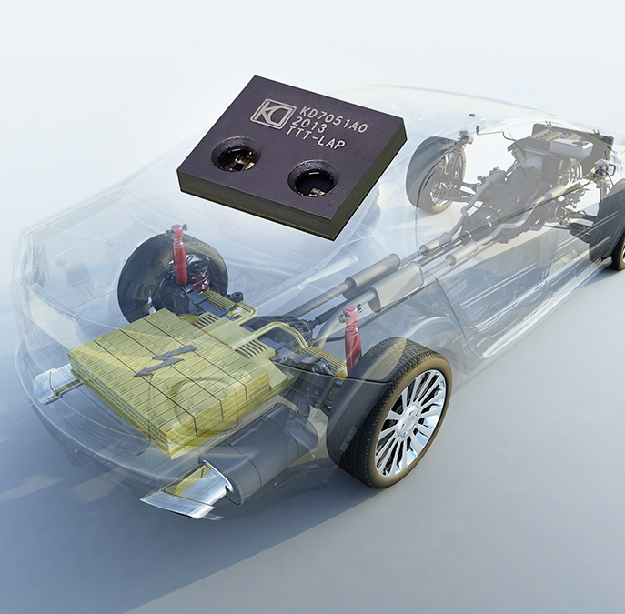 |  | Image 1: New KD7051 transceiver by KDPOF for automotive networking convinces with reduced cost and footprint  Copyright: Gettyimages  Download: https://www.ahlendorf-news.com/media/news/images/KDPOF-KD7051-automotive-fiber-optics-H.jpg
Image 2: Carlos Pardo is CEO and Co-Founder of KDPOF

Copyright: KDPOF
Download: https://www.ahlendorf-news.com/media/news/images/KDPOF-Carlos-Pardo-H.jpg

About KDPOF

Fabless semiconductor supplier KDPOF provides innovative high-speed optical networking for harsh environments. Making gigabit communications over fiber optics a reality, KDPOF technology supplies 1 Gb/s POF links for automotive, industrial, and home networks. Founded in 2010 in Madrid, Spain, KDPOF offers their cost-effective technology as either ASSP or IP (Intellectual Property) to be integrated in SoCs (System-on-Chips). The adaptive and efficient system works with a wide range of optoelectronics and low-cost large core optical fibers, thus delivering carmakers low risk, low cost and short time-to-market. More information is available at www.kdpof.com.

KDPOF Knowledge Development for POF, S.L.
Ronda de Poniente 14, 2ª Planta
28760 Tres Cantos, Spain
E pr@kdpof.com
T +34 918043387

Media Contact:
Mandy Ahlendorf
ahlendorf communication
E ma@ahlendorf-communication.com
T +49 89 41109402

