EVK9351AUT Accelerates Project Launch for Optical Gigabit Connectivity

KDPOF Integrates KD9351 and KD1053 in Extensive Evaluation Kit to Facilitate Project Entry for Safe Backbone and ADAS Sensor Links in Vehicles

Madrid (Spain) May 11, 2021 – KDPOF – leading supplier for gigabit connectivity over fiber optics – presents the new extensive evaluation kit EVK9351AUT for a quick and easy project launch of optical gigabit connectivity in vehicles. “Our new EVK9351AUT equips carmakers, suppliers, and test houses to fully evaluate the KDPOF automotive transceivers KD9351 and KD1053 for automotive optical 1000BASE-RHC PHY implementation,” explained Carlos Pardo, CEO and Co-founder of KDPOF. “We thus support our recently announced new integrated KD9351 Fiber Optic Transceiver (FOT) for comprehensive evaluation.” The platform provides all the functional and performance evaluation capabilities requested by automotive OEMs, Tier1s, and test houses. It therefore enables product designers to successfully evaluate KDPOF’s technology and shorten the time-to-market. The new KD9351, in combination with the continuing KD1053 IC, cuts the cost for 1 Gb/s optical connectivity by 30 percent, providing competitive pricing for EMC critical or galvanic isolated critical links. Applications include safe Ethernet backbones and sensor links for advanced driver assist systems (ADAS).

Evaluation Kit for 1000BASE-RHC Automotive Bridge

The extensive evaluation kit EVK9351AUT contains 2 EVB9351AUT evaluation boards, 2 evaluation board metal enclosures (optional), 2 1000BASE-T SFP modules, 2 100BASE-TX SFP modules (optional), 1 USB2ALL monitoring box, 1 optical harness, 2 Cat. 5e UTP cables, 2 direct-attach passive SFP twinax cables (optional), as well as user and design documentation.

The evaluation boards can operate at 100 and 1,000 Mb/s. A single version of a board is compatible with multiple headers and harnesses from different manufacturers. The user can plug a standard SFP module into the cage and have media converter functionality supporting Wake-Up & Sleep. Complementary items can be provided, such as optical harness, loopback SFP, or SFP direct-attach passive twinax cable. The board is configured in an EEPROM memory. The provided SDK allows the generation of binaries for different configuration options and flashing of the EEPROM. In addition, control and status of the KD1053 transceiver is accessed through the GUI (included in the SDK), which may be run on a computer connected via a USB2All module. The GUI includes several panels that provide complete access to the KDPOF transceiver, providing information on the link status and its parameters. User and design documentation is included in order to simplify the evaluation and the development of automotive end products based on the two-part numbers.

The EVK9351AUT evaluation kit can be ordered via sales@kdpof.com.

Words: 421

More information:
EVK9351AUT evaluation kit: https://t1p.de/KDPOF-EVK9351AUT
EVB9351AUT evaluation board: https://t1p.de/KDPOF-EVB9351AUT

Images

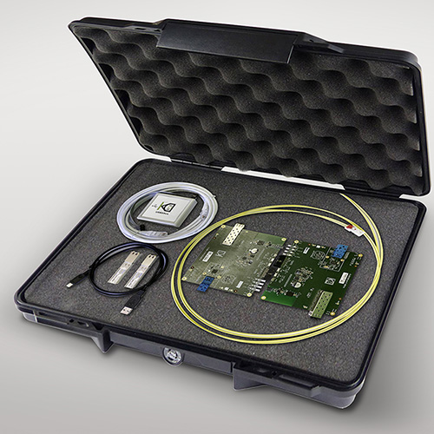 |  | Image 1: Extensive evaluation kit EVK9351AUT from KDPOF eases project start for optical gigabit connectivity  Copyright: KDPOF  Download: https://www.ahlendorf-news.com/media/news/images/KDPOF-evk9351aut-eval-kit-automotive-fiber-optics-H.jpg
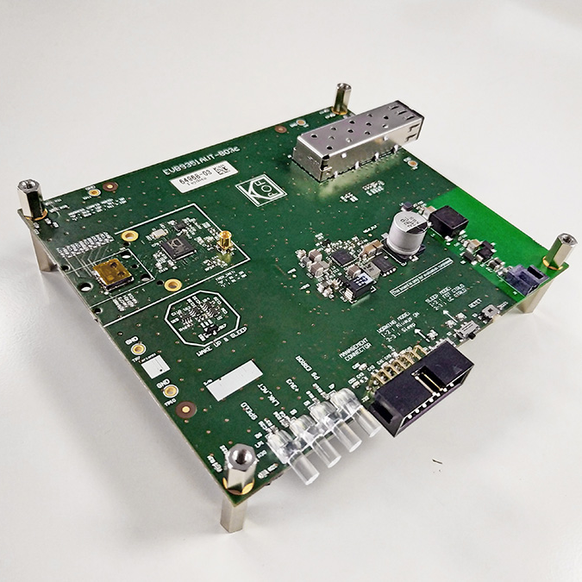 |  | Image 2: Evaluation board included in the evaluation kit EVK9351AUT for 1000BASE-RHC automotive bridge  Copyright: KDPOF  Download: https://www.ahlendorf-news.com/media/news/images/KDPOF-evaluation-board-evk9351aut-automotive-fiber-optics-H.jpg
Image 3: Carlos Pardo is CEO and Co-Founder of KDPOF

Copyright: KDPOF
Download: https://www.ahlendorf-news.com/media/news/images/KDPOF-Carlos-Pardo-H.jpg

About KDPOF

Fabless semiconductor supplier KDPOF provides innovative high-speed optical networking for harsh environments. Making gigabit communications over fiber optics a reality, KDPOF technology supplies 1 Gb/s POF links for automotive, industrial, and home networks. Founded in 2010 in Madrid, Spain, KDPOF offers their cost-effective technology as either ASSP or IP (Intellectual Property) to be integrated in SoCs (System-on-Chips). The adaptive and efficient system works with a wide range of optoelectronics and low-cost large core optical fibers, thus delivering carmakers low risk, low cost and short time-to-market. More information is available at www.kdpof.com.

KDPOF Knowledge Development for POF, S.L.
Ronda de Poniente 14, 2ª Planta
28760 Tres Cantos, Spain
E pr@kdpof.com
T +34 918043387

Media Contact:
Mandy Ahlendorf
ahlendorf communication
E ma@ahlendorf-communication.com
T +49 89 41109402

