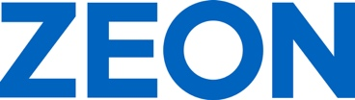

ZEON Europe GmbH
Hansaallee 249
40549 Düsseldorf
Germany
Phone +49-211-5267-0
Fax +49-211-5267-160
Email zeinfo@zeon.eu
Public Relations: Melanie Grape (ext. 131)

www.zeon.eu
P R E S S R E L E A S E

DKT IRC 2021: ZEON Presents New Specialty Rubbers

Enhanced Performance and Reduced Carbon Footprint:
Bio-Hydrin®ECO, HyTemp®H570, Hydrin DP5227, Hydrin DP5250

Duesseldorf (Germany) June 23, 2022 – ZEON Europe GmbH – European subsidiary of ZEON Corporation, Japan, a leading and globally operating producer of specialty polymers – will introduce several new specialty rubbers at the Deutsche Kautschuk Tagung (DKT; German Rubber Conference) and International Rubber Conference (IRC) in Nuremberg, Germany, June 27-30, 2022, a triannual international major event for the rubber industry. “We are very much looking forward to finally meeting our customers personally and displaying our innovations at Stand 524 in Hall 9,” stated Hubert Thimm, Commercial Director of ZEON Europe GmbH. “In response to the increasing demands on polymer materials, we have developed a range of new high-performance materials that feature enhanced performance, reduced carbon footprint, and improved resistance to new types of automotive service fluids and media.”

Bio-Hydrin®ECO Significantly Reduces CO₂ Footprint

With the new Bio-Hydrin® ECO, ZEON supports their customer in reaching the goal of reducing the CO₂ footprint of elastomer products. The epichlorohydrin monomer used by Bio-Hydrin® is derived from the by-product of biodiesel production originating from sustainable agricultural sources. Bio-Hydrin® fully maintains the properties of standard Hydrin® based on crude oil sources. The substitution with 1 kg Bio-Hydrin® may reduce the carbon footprint by the equivalent of up to 2.56 kg CO₂ (based on calculations by the producer of bio-epichlorohydrin). Application areas include many automotive and industrial components.
At DKT Solutions, Dr. Marcus Santoso, Commercial Manager at ZEON Europe GmbH, will present “Sustainable Epichlorohydrin Rubber (Bio Hydrin®) - a contribution to reduce the carbon footprint” on Monday, June 27, at 14:40 and on Wednesday, June 29, at 11:00.

Improved Low Temperature Performance with HyTemp®H570

ZEON has added new grades to the well-proven HyTemp® ACM polymer range. The new HyTemp®H570 offers improved low temperature performance and excellent fluid resistance whilst providing the same high temperature resistance characteristic of HT-ACM. The family of ACM elastomers known as high temperature polyacrylate (HT-ACM) use the most heat resistant ACM technology to date. Therefore, they have better heat resistance than traditional ACM materials due to optimization of backbone monomers, along with improved cross-linking technology. HyTemp® ACM has long been established in the automotive market for sealing and gasket applications as well as for hose applications for air and fluid management systems of the engine. Their excellent resistance to high temperature and automotive fluids makes them ideal for use in e-mobility sealing applications.

New Hydrin Grades DP5227 and DP5250 for Enhanced Processing

The new Hydrin DP5227 and DP5250 grades complement the Hydrin® HT-ECO series for enhanced processing and increased upper temperature resistance compared to Standard Hydrin® ECO copolymer and terpolymer grades. In addition, they provide several cure system options including Sulphur and Peroxide, as well as Triazine and Bisphenol for flexibility in moulding, calendaring and extrusion processes, and balance of properties. The wide range of applications embraces automotive sealing and fuel hoses as well as industrial components such as diaphragms and oil hoses.

Words: 499

Keywords: ZEON, Specialty rubber, DKT, Deutsche Kautschuk Tagung, IRC, International Rubber Conference, CO2 footprint, Bio-Hydrin ECO, HyTemp H570, Hydrin DP5227, Hydrin DP5250, automotive, sealing hose, industrial, specialty elastomer, polymer, and specialty chemical, Hubert Thimm

Images

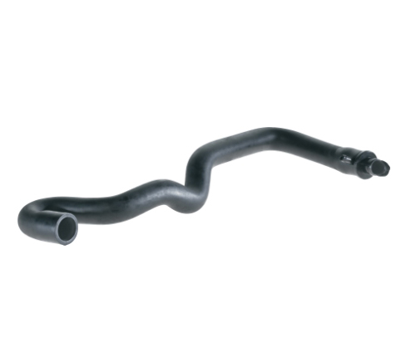 | Image 1: Bio-Hydrin® ECO from ZEON reduces CO₂ footprint for automotive and industrial applications  Copyright: ZEON Europe GmbH  Download: https://www.ahlendorf-news.com/media/news/images/zeon-bio-hydrin-eco-auto-industrial-H.jpg
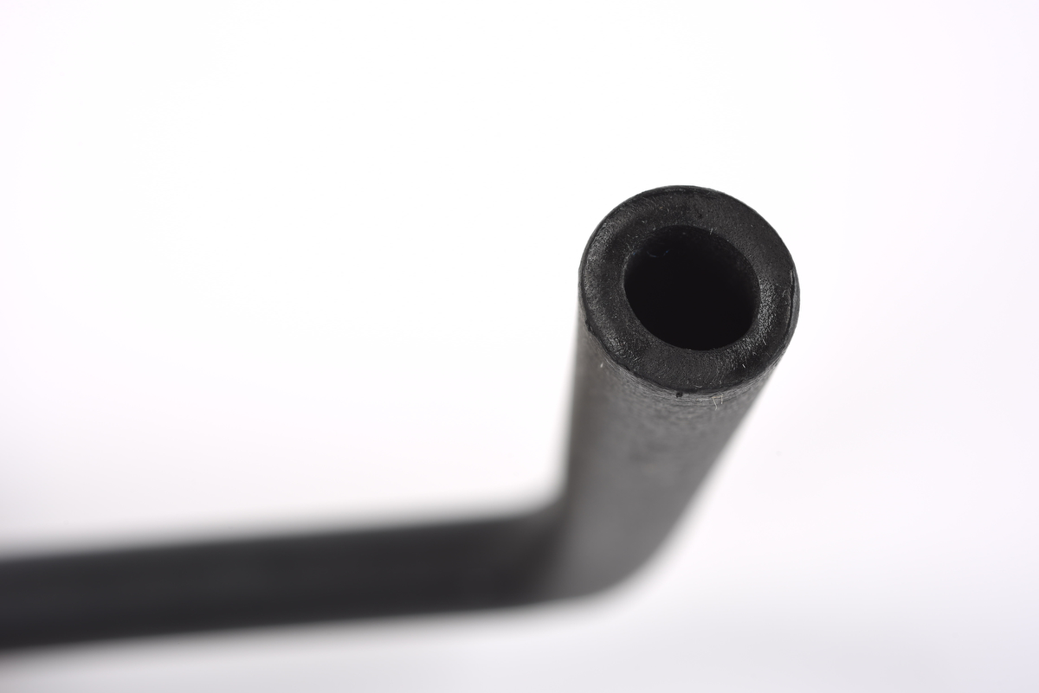 | Image 2: ZEON presents new grades of Hydrin® HT-ECO for automotive sealing and fuel hoses  Copyright: ZEON Europe GmbH  Download: https://www.ahlendorf-news.com/media/news/images/zeon-hydrin-ht-eco-DP5227-DP5250-H.jpg
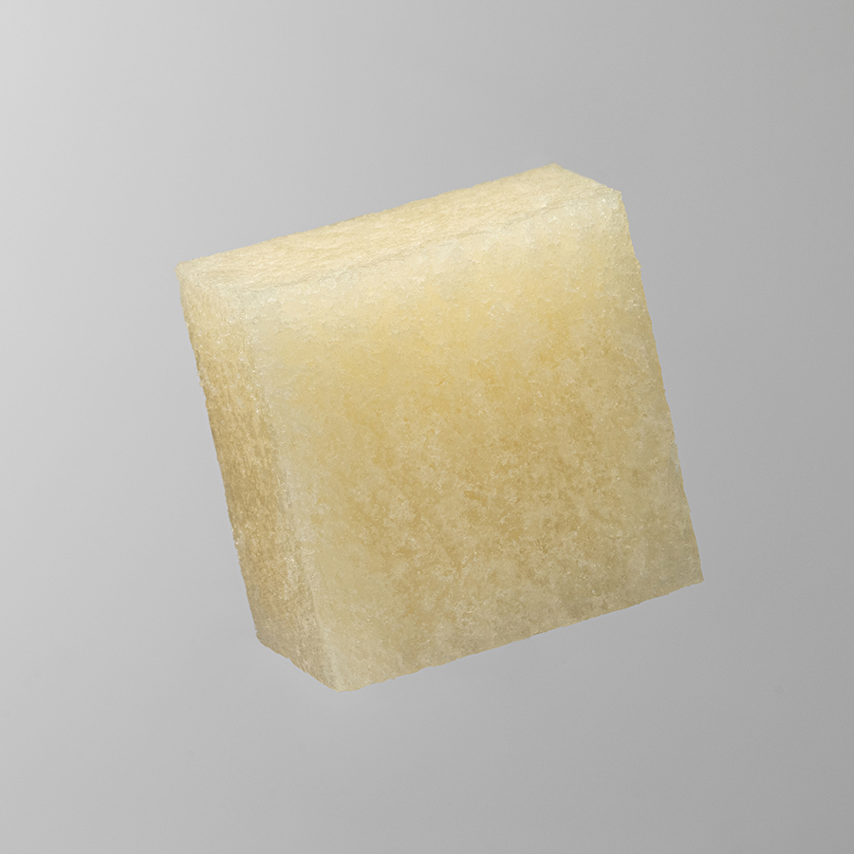 | Image 3: New HyTemp®H570 from ZEON offers improved low temperature performance and excellent fluid resistance  Copyright: ZEON Europe GmbH  Download: https://www.ahlendorf-news.com/media/news/images/zeon-ACM-HyTemp-H570-H.jpg
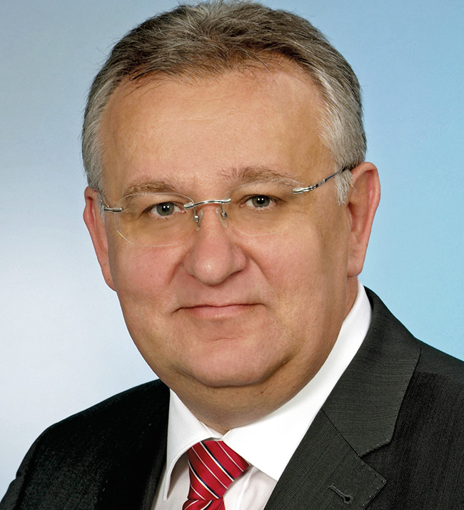 | Image 4: Hubert Thimm is Commercial Director of ZEON Europe GmbH  Copyright: ZEON Europe GmbH  Download: http://www.ahlendorf-news.com/media/news/images/Zeon-Hubert-Thimm-2-H.jpg

COMPANY PROFILE – ZEON Corporation is the world leader in specialty elastomers, polymers, and specialty chemicals. ZEON is one of the top producers of polymers in the world, operating a global network of plants in Asia and North America, and research and development laboratories in Japan, USA, China, and Singapore. With more than 70 years in business and consolidated sales of ca. US$ 3 billion, ZEON has both the experience and the expertise in C4 and C5 chemistry to offer a wide range of world class products. ZEON employs over 3,900 people worldwide, with global headquarters in Tokyo and regional sales offices all over Europe, America and Asia. “We realize the importance of having a close partnership with (potential) customers worldwide. Therefore, our resources in sales and technical service always put great effort into technical cooperation to bring positive momentum to our customers. Then, together we will find the optimum solution,” Hubert Thimm, ZEON Europe Commercial Director explained.

While ZEON is continuously settled in the traditional global elastomer business (60% of total business), the specialty material business has been progressively built up and has been growing significantly. ZEON specialty materials will provide material solutions for the future world in terms of sustainable energy sources, electromobility, digitalisation and media, as well as modern lifestyle and health care.

Media Contact

Melanie Grape
Zeon Europe GmbH
E-Mail: melanie.grape@zeon.eu
Phone: +49 (0)1738970420
Hansaallee 249
DE-40549 Düsseldorf

