February 28, 2023

KDPOF and Würth Elektronik Cooperate for Optical Automotive Multi-gigabit Ethernet

Presentation of Next-generation High-speed Connectivity up to 50 Gb/s over Glass Optical Fiber for ADAS and Connected Driving

Madrid (Spain) – KDPOF (leading supplier for gigabit connectivity over fiber optics in harsh environments) proudly announced their technological cooperation with Würth Elektronik (one of the leading manufacturers of electronics and electromechanical components in Europe) to advance automotive multi-gigabit Ethernet over fiber optics.
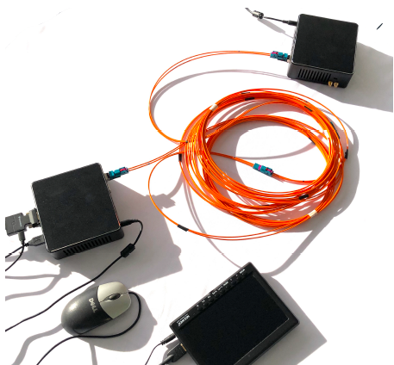
“We are honored to have Würth Elektronik as a partner for our next-generation optical high-speed connectivity reference designs in vehicles,” stated Carlos Pardo, CEO and Co-founder of KDPOF. “As the auto industry approaches the 100 Gb/s*m speed-length threshold, the move from copper to optical physical data transmission media is picking up speed.”
Image 1: Presentation of automotive high-speed link over glass optical fiber.

“With a growing portfolio of Automotive Grade components, we are able to support several innovative applications such as ADAS,” said Alexander Gerfer, CTO of the Würth Elektronik eiSos Group. “Our partnership with KDPOF marks an important step towards strengthening our presence in the field of automotive in-vehicle connectivity, where our EMC know-how is highly requested.”

Robust, EMC-safe, and Low-Cost In-vehicle High-speed Links

In order to fulfill the needs of future connected and automated vehicles, KDPOF’s next-generation automotive Ethernet provides high-speed links up to 100 Gb/s over glass optical fibers (GOF). Instead of various port components, the new solution delivers a single-component, complete automotive multi-gigabit system. Optical Ethernet connectivity perfectly solves vehicles' challenges and electrical interference thanks to its unbeatable electromagnetic compatibility, reliability, and low cost.
The new connector systems are very small, light-weight, and extremely inexpensive compared to the previous ones. With cost-down and consistency in focus, optics, fibers, connectors, and electronics already developed for nGBASE-SR are leveraged. Further specifications include 980 nm VCSEL (Vertical-Cavity Surface-Emitting Laser), multimode OM3 fiber, and connectors. Applications comprise display connectivity, sensor-fusion backbone, and ADAS sensors, such as cameras, radar, and lidar.
KDPOF will present their latest demo setup, demonstrating automotive high-speed links with a connector from MD Elektronik, together with Würth Elektronik at stand 110 in hall 2 at Embedded World international trade show on March 14, 2023 in Nuremburg. Germany. In addition, KDPOF will show the demo at Automotive Ethernet Congress from March 22 to 23, 2023 in Munich, Germany.
Words: 372

Keywords: KDPOF, IEEE, fiber optics, KD1053, KD9351, KD7251, gigabit, automotive, automotive Ethernet, in-vehicle connectivity, automotive network, IVN, ADAS, autonomous vehicle, automated driving, connected vehicles, EMC, EMC-safe, photonics, multi-gigabit, Würth Elektronik, embedded world, automotive ethernet congress, md elektronik

Images
Image 1: KDPOF together with Würth Elektronik presents automotive high-speed links over glass optical fiber
Copyright: KDPOF
Download: https://www.ahlendorf-news.com/media/news/images/KDPOF-wuerth-high-speed-demo-H.jpg

Image 2: Carlos Pardo is CEO and Co-founder of KDPOF
Copyright: KDPOF
Download: https://www.ahlendorf-news.com/media/news/images/KDPOF-Pardo-Carlos-4-H.jpg

Image 3: Alexander Gerfer is CTO of the Würth Elektronik eiSos Group
Copyright: Würth Elektronik
Download: https://www.ahlendorf-news.com/media/news/images/wuerth-elektronik-alexander-gerfer-H.jpg

About the Würth Elektronik eiSos Group
Würth Elektronik eiSos Group is a manufacturer of electronic and electromechanical components for the electronics industry and a technology company that spearheads pioneering electronic solutions. Würth Elektronik eiSos is one of the largest European manufacturers of passive components and is active in 50 countries. Production sites in Europe, Asia and North America supply a growing number of customers worldwide. The product range includes EMC components, inductors, transformers, RF components, varistors, capacitors, resistors, quartz crystals, oscillators, power modules, Wireless Power Transfer, LEDs, sensors, connectors, power supply elements, switches, pushbuttons, connection technology, fuse holders and solutions for wireless data transmission. The unrivalled service orientation of the company is characterized by the availability of all catalog components from stock without minimum order quantity, free samples and extensive support through technical sales staff and selection tools.
Würth Elektronik is part of the Würth Group, the global market leader in the development, production, and sale of fastening and assembly materials, and employs 8,200 people. In 2022, the Würth Elektronik Group generated sales of 1.33 Billion Euro. Würth Elektronik: more than you expect!
Further information at www.we-online.com

About KDPOF
Fabless semiconductor supplier KDPOF provides innovative high-speed optical networking for harsh environments. KDPOF made gigabit communications overstep-index plastic optical fiber (SI-POF) a reality for automotive. Founded in 2010 in Madrid, Spain, KDPOF offers its cost-effective technology as a fully qualified automotive-grade ASSP. KDPOF’s technology makes use of innovative digital adaptive algorithms to maximize the receiver’s sensitivity. This supports high-yield and reliable optoelectronics production in low-cost CMOS submicron nodes, delivering carmakers low risk, low cost, and short time-to-market.
More information is available at https://www.kdpof.com

KDPOF Knowledge Development for POF, S.L.
Ronda de Poniente 14, 2ª Planta
28760 Tres Cantos, Spain
E-Mail: pr@kdpof.com
Phone: +34 918043387

MEDIA CONTACT
Mandy Ahlendorf
ahlendorf communication
E-Mail: ma@ahlendorf-communication.com
Phone: +49 89 41109402

