FIVEberry Establishes Broad and Easy Access to RISC-V Technology

ARIES Embedded Launches a ‘Community-Flavor-Board’ for Quick Project Entry and Fast Prototyping Based on OSM-compatible MSRZFive SiP with RZ/Five Microprocessor from Renesas

Fuerstenfeldbruck (Germany) May 25, 2023 – ARIES Embedded, specialist in embedded services and products, is proud to announce the new FIVEberry embedded system offering a smooth and fast start into computing projects. The FIVEberry integrates the powerful, OSM-compatible MSRZFive system-in-package (SiP) based on the single-core microprocessor RZ/Five by Renesas Electronics onto a compact evaluation board. The RZ/Five microprocessor has a RISC-V CPU core (AX45MP single) running at 1.0 GHz. “Our new baseboard supports all necessary features to make the first steps with the RISC-V CPU core,” stated Andreas Widder, Managing Director of ARIES Embedded. “This entry-level platform serves an expanded user community to develop and debug drivers and bootloaders, and even use it in prototype setups.” The RZ/Five general-purpose microprocessor units (MPUs) from Renesas are built around a 64-bit RISC-V CPU core and employ the AX45MP from Andes Technology Corporation, based on the RISC-V CPU instruction set architecture (ISA).

FIVEberry Provides Easy and Fast Design Start

The peripheral functions of the small, low-cost CPU application board FIVEberry include support for multiple interfaces, including two Gigabit Ethernet channels, two USB 2.0 channels, and two CAN channels. In addition, the baseboard offers dual A/D converter modules, making it ideal for applications such as entry-class social infrastructure gateway control and industrial gateway control.

The FIVEberry is driven by the powerful and versatile system-in-package MSRZFive from ARIES Embedded, which in the smallest size “S” concentrates extensive functionality on the board measuring just 30 by 30 mm each. The module conforms to SGET’s OSM standard and offers an LCD controller. It supports 512 MB to 4 GB of DDR4 RAM, SPI-NOR flash and optionally 4 GB of eMMC NAND flash. The numerous interfaces include camera input (MIPI-CSI), display output (Parallel-IF), USB2.0 2ch, SD 2ch, CAN (CAN-FD), and Gigabit Ethernet 2-Channel. The temperature range starts at -25 °C to +85 °C and goes up to -40 °C to +85 °C for industrial environments.

ARIES Embedded is incorporated in Renesas' Preferred Partner Program. In the partnership with Renesas, the embedded specialists bundle their knowledge to further optimize service for customers in the field of industrial electronics.
OSM – Open Standard Module™

The idea of all Open Standard Modules™ by SGET (Standardization Group for Embedded Technologies e. V.) is to create a new, future proof and versatile standard for small-size, low-cost embedded computer modules, combining different characteristics, such as to be completely machine processible during soldering, assembly, and testing. Further, it offers different possible packages for direct PCB soldering without a connector. In addition, it provides pre-defined soft- and hardware interfaces as well as open-source in soft- and hardware. The Open Standard Module™ specification allows development, production, and distribution of embedded modules for the most popular MCU32, ARM and x86 architectures. For a growing number of IoT applications, the standard helps to combine the advantages of modular embedded computing with increasing requirements regarding costs, space, and interfaces.

The FIVEberry will be available in Q3 2023.

Words: 516

More information:
FIVEberry: https://www.aries-embedded.com/evaluation-kit/cpu/rzfive-renesas-riscv-msrzfive-osm-ethernet-can-fiveberry
MSRZFive: https://www.aries-embedded.com/system-on-module/cpu/rzfive-renesas-riscv-msrfive-osm-dual-ethernet-can
OSM standard: https://sget.org/standards/osm/

Keywords: Aries Embedded, Andreas Widder, FIVEberry, MSRZFive, embedded system, industrial, Renesas, system-in-package, gateway control, evaluation kit, baseboard, OSM, RISC-V, SGET

Images

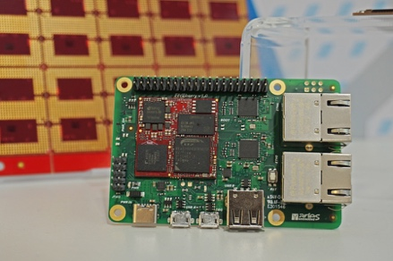 | Image 1: ARIES Embedded presents FIVEberry baseboard for broad and easy access to RISC-V technology  Copyright: ARIES Embedded GmbH  Download: https://www.ahlendorf-news.com/media/news/images/aries-embedded-FIVEberry-H.jpg
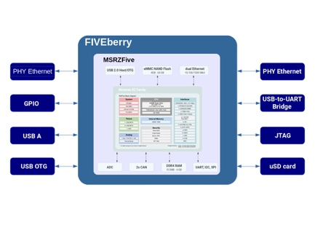 | Image 2: Core of the FIVEberry is the OSM-compatible, powerful MSRZFive SiP based on Renesas  Copyright: ARIES Embedded GmbH  Download: https://www.ahlendorf-news.com/media/news/images/aries-embedded-FIVEberry-block-diagram-H.jpg
Image 3: Andreas Widder is Managing Director of ARIES Embedded GmbH

Copyright: ARIES Embedded GmbH
Download: http://www.ahlendorf-news.com/media/news/images/aries-embedded-Andreas-Widder-H.jpg

About ARIES Embedded

ARIES Embedded provides hardware and software development and standard products for industrial and agricultural sectors. The 2001 founded embedded specialist headquartered in Fuerstenfeldbruck, Germany, focuses on FPGA technology and open-source software. The portfolio comprises of modular systems for flexible and fast use in functional prototypes, pilot series and mass production. On customer request, ARIES Embedded individually customizes standard products in accordance with project requirements. Further information is available at www.aries-embedded.com.

ARIES Embedded GmbH
Schöngeisinger Str. 84
DE-82256 Fürstenfeldbruck
Fon: +49 8141 36 367 0
Fax: +49 8141 36 367 67
www.aries-embedded.com
info@aries-embedded.de

Media Contact
Mandy Ahlendorf
ahlendorf communication
ma@ahlendorf-communication.com
+49 89 41109402

